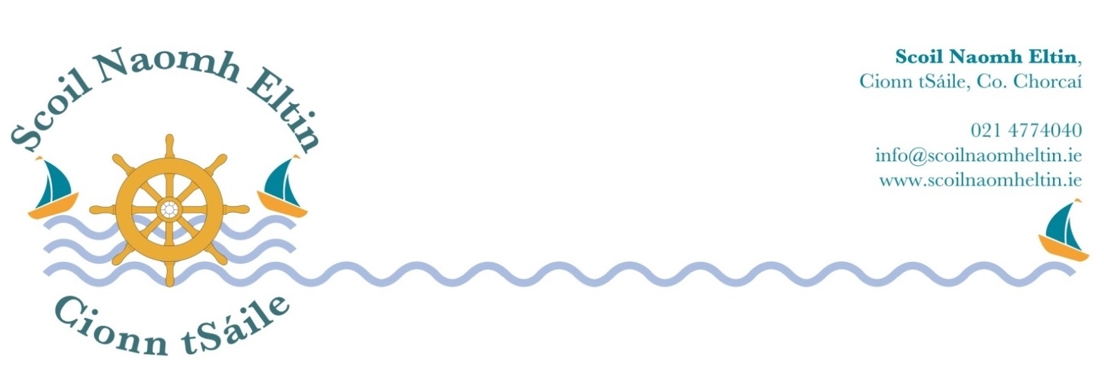

1st Class Booklist
2018 - 2019

Gaelige: Bua Na Cainte 1 EDCO

English: The Four Friends Activity Book Folens
Two Little Frogs Folens
Handwriting Made Easy Looped Style 1 CJ Fallon
Jolly Grammar 1 Pupil Book

Maths: Busy at Maths 1 CJ Fallon
Busy at Maths 1 Shadow Book CJ Fallon
New Wave Mental Maths 1 (Revised Edition) Prim- Ed
Time for Tables EDCO

Religion: Grow in Love 1st Class Veritas

Copies and Folders:

1 A5 Spelling Notebook
1 Maths Copy (10mm squared boxes)
5 88 Page Copies
2 A4 Plastic Envelope Folders
1 Project Copy 15A

Please have all books and copies covered in clear plastic and clearly labelled on the front covers.

Children will need pencils, eraser, pencil sharpener, ruler and colouring pencils.

I would ask that your child has a child-safe scissors and a large pritt-stick, which should both be clearly labelled. These will be collected and held in safe keeping by the class teacher for use during the year.

The following monies will be collected from each child at the beginning of the school year 2018/2019:

Arts, crafts and photocopying €25.00

Pupil Personal Accident Insurance Cover € 6.50

Bua na Cainte Interactive Resources € 3.00

Rainbow Oral Language Interactive Resources € 3.00

Aladdin Connect (School Communication System) € 4.00

Literacy Shared Readers € 3.00

Scoil Naomh Eltin Homework Journal € 3.00
(Your child will receive this journal at the start of the school year)

Please use e-payment link which you will receive by text in August.
Otherwise please pay at school office.
If paying by cheque, please make payable to SCOIL NAOMH ELTIN.

