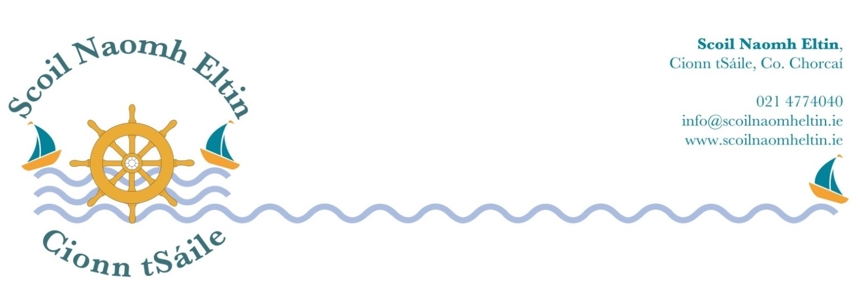

4th Class Booklist
2018 - 2019

Gaeilge: Abair Liom F Folens

English: Handwriting Made Easy Looped Style 4th class CJ Fallon
Word Wise 4 CJ Fallon

Maths: Master your Maths 4 CJ Fallon
Fallons Table Book Fallons

Music: Tin Whistle in Key of D

Copies:

1 A4 Hardback Copy for Homework
2 Maths Copies
6 x 88 page copies

Please have all books and copies covered in clear plastic and clearly labelled on the front covers.

Children will need pencils, eraser, pencil sharpener, long ruler, red biro, blue biro, colouring pencils and highlighters.

I would ask that your child has a child-safe scissors and a large pritt-stick, which should both be clearly labelled. These will be collected and held in safe keeping by the class teacher for use during the year.

The following monies will be collected from each child at the beginning of the school year 2018/2019:

Arts, crafts and photocopying €25.00
Pupil Personal Accident Insurance € 6.50

Aladdin Connect (School Communication System) € 4.00

Literacy Shared Readers € 3.00
Scoil Naomh Eltin Homework Journal € 3.00
(Your child will receive this journal at the start of the school year)

Please use e-payment link which you will receive by text in August.
Otherwise please pay at school office.
If paying by cheque, please make payable to SCOIL NAOMH ELTIN.

