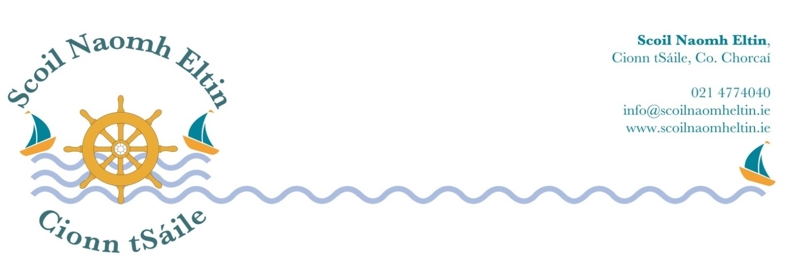

5th Class Booklist
2018 – 2019

Gaeilge: Abair Liom G Folens English Irish Dictionary – Pocket Size Collins

English: Word Wise 5 CJ Fallon

Handwriting Made Easy Looped Style 4 CJ Fallon

Maths: Master your Maths 5 CJ Fallon
Fallons Table Book Fallons

Geography: Mapwise 2 Fifth & Sixth EDCO

Religion: Grow in Love Fifth Class Veritas

Music: Tin Whistle in Key of D

Copies & Folders:

Display Folder: 80 Pockets
3 Maths Copies
8 Lined Copies (120 page)
1 X A4 Hardback

Please have all books and copies covered in clear plastic and clearly labelled on the front covers.

School Equipment:

Pencil Case 1 should contain a set of markers, colouring pencils and pritt stick.

Pencil Case 2 should contain 3 Red pens, 3 Blue Pens, 3 Pencils, Ruler, Eraser and Pencil Sharpener.

I would ask that your child has a child-safe scissors, which should be clearly labelled. This will be collected and held in safe keeping by the class teacher for use during the year.

Maths Equipment:
Maths Set (labelled with name)

The following monies will be collected from each child at the beginning of the school year 2018/2019:

Arts, crafts and photocopying €25.00
Pupil Personal Accident Insurance € 6.50

Work Sheets: Bí ag Scríobh, Bí ag Caint, €10.00
Maths in Focus (will be used in 5th & 6th class)

Aladdin Connect (School Communication System) € 4.00

Literacy Shared Readers € 3.00
Scoil Naomh Eltin Homework Journal € 3.00
(Your child will receive this journal at the start of the school year)

Please use e-payment link which you will receive by text in August.
Otherwise please pay at school office.
If paying by cheque, please make payable to SCOIL NAOMH ELTIN.

