Scoil Naomh Eltin Home-School Assignments
Class Level: 5th Class Week Beginning: Monday 20th April
Dear students,
I hope that you all had a nice break from school work over the past two weeks and you and your family are looking after each other. It is very important to be patient with one another during this time.
Email Contact
As mentioned in the email that I sent out before the holidays, I would love to see some of your work as I know that you were all working very hard before the holidays and it is important that your hard work is acknowledged. If you wish you may email us a photo of one or two pieces of your best work during the week (see email addresses below). We can display it on our class webpage. If you don’t have your own email address perhaps your parents/guardians might assist you. Let us know if you would prefer to not have your art/work displayed on the school website.
Website and Links
Rather than sharing links in this document we have created a Padlet website to hold all the online links we mention. The link for this is listed below and is also on the class blog on the school website:
https://padlet.com/SNE5th2020/xikutk3t4inkesgg
Routine
The work-bank this week includes a suggested daily routine. This is just a suggested routine. I know many of you have already found a routine which works for you each day/week. If you have, stick with it! If not, try out the suggested routine and change it to suit your situation at home.
Practice Learning
As mentioned previously, the work-bank is not a list of tasks which must be completed. Try to engage with the core subjects (Maths, English, Gaeilge) most days if you can. It is important that you, as students, continue to practice learning of some kind though. Since you started school all those years ago, you have developed a range of learning skills. It is important to continue to practice learning whether you use this work-bank or choose a passion project of your own to work on over a number of days. Whatever you learn, please share it with us by email. Learning is kind of a big deal for us!!!
Ms O’Sullivan & Mr Murray
Orla.osullivan@scoilnaomheltin.ie Liam.murray@scoilnaomheltin.ie
(the teacher’s first names are revealed! 😵)
Suggested Routine:
Time | Item/Subject
8am | Morning routine – wake up, breakfast, etc.
9am | Maths – from work bank
9.30am | PE with Joe Wicks streamed live on YouTube (or save it for later)
10am | Gaeilge – from work bank
10.30am | English - Find a quiet corner and read
11am | Home School Hub on RTÉ
12pm | Break/ lunch/ free time
1pm | Optional Challenges
3pm | Free time

April 20th to 24th Optional Challenges
PE | PE Challenge  Have a go at Joe Wicks PE classes that are on every morning live on YouTube at 9.30am. Link available on the Padlet website.
SPHE | SPHE Challenge:  Start (or continue to keep) a diary of you and your family’s experience during the Covid-19 Pandemic. Record your observations, thoughts and feelings each day in your copybook. Choose one copybook to keep all your diary entries in and be sure to date each diary entry. These will be used to create a class book when we return. Diary entries don’t need to be long – just a few sentences each day. They are really interesting to read back over when you have a few weeks’ worth built up.  If you’re not sure what to write News2day on the RTE PLayer could give you some ideas.
Writing | Writing Challenges for this week:  We have more chocolate than we can eat in our houses so we thought we might share with you – as a prize for a 5th Class only story writing competition!  You can write your story in a copy and take a photo or type it and send to us by email. The deadline for entries will be the 30th April. The winner will be announced on the school website.
SESE | Science Challenge  This week our challenge is to look out for some Irish garden birds. Here is a list and pictures of some that you might see. If you find one (or maybe a few) keep track of their names and the date, time and location of when you found them, we will keep a list and work as a team to track all of them!  In West Cork this week there was some great news about a very famous white-tailed eagle
Art | Art Challenge:  Will Sliney is running a daily art challenge, you can find it if you search for #wewilldraw

Monday | Maths: Busy at Maths  New topic – directed numbers (don’t be alarmed!)  We are going to assign some new learning this week in maths. The link is available in the Maths section of the Padlet webpage. This will be the only maths this week though!  - Busy at Maths Online Weblink Tutorial 75  - Busy at Maths p125 – read the example and complete questions 1, 2 and 3  Any issues just email.  English:  - Begin planning your story for the writing competition.  - New Wave English: Correct Day 76, 77, 78 (answers at end of doc)  5th A: Explore the World Book Online Website (must access it through the link in the padlet). On Thursday and Friday you will be asked to review the website and tell me what about one topic you learned about. You can type your review or write and photo it. I won’t put it on the classroom blog if you request that I don’t.  5th B Novel Work: Cogheart – Read one chapter per day or at your own pace.  Gaeilge: Choose one or two each day  - Léigh sa Bhaile (lch 10 of 120) Comórtas Bácála na hÉireann  Listen to the mp3 file and then read the text and answer the questions in your copy each day.  - 10 mins of Duolingo  - Cúla 4 ar scoil. This is on tv every day at 10.00am - 10.30am or you can watch it here each day. (Link on padlet website).
Tuesday | Maths: Busy at Maths  New topic – directed numbers (positive and negative numbers)  - Busy at Maths Online Weblink Tutorial 76  - Busy at Maths p126 – read the example and complete questions 1 and 2 (and the challenge if you’re ready)  Any issues just email.  English:  - New Wave English Day 81  5th A: Explore the World Book Online Website (must access it through the link in the padlet). On Thursday and Friday you will be asked to review the website and tell me what about one topic you learned about. You can type your review or write and photo it. I won’t put it on the classroom blog if you request that I don’t.  5th B Novel Work: Cogheart – Read one chapter per day or at your own pace.  Gaeilge: Choose one or two each day  - Léigh sa Bhaile (lch 11 of 120) Ceacht Gaeilge  - Listen to the mp3 file and then read the text and answer the questions in your copy each day.  - 10 mins of Duolingo  - Cúla 4 ar scoil. This is on tv every day at 10.00am - 10.30am or you can watch it here each day. (Link on padlet website).
Wednesday | Maths: Busy at Maths  New topic – directed numbers (positive and negative numbers)  - Khan Academy tutorial on directed numbers - see the Maths section padlet website for a link  - Busy at Maths p127 – complete all questions 1-15 (not 16 today)  Any issues just email.  English:  - New Wave English Day 82  5th A: Explore the World Book Online Website (must access it through the link in the padlet). On Thursday and Friday you will be asked to review the website and tell me what about one topic you learned about. You can type your review or write and photo it. I won’t put it on the classroom blog if you request that I don’t.  5th B Novel Work: Cogheart – Read one chapter per day or at your own pace.  Gaeilge: Choose one or two each day  - Léigh sa Bhaile (lch 12 of 120) Fleadh Cheoil  - 10 mins of Duolingo  - Cúla 4 ar scoil. This is on tv every day at 10.00am - 10.30am or you can watch it here each day. (Link on padlet website).
Thursday | Maths:  New topic – directed numbers (positive and negative numbers)  - Khan Academy tutorials on directed numbers - see the Maths section padlet website for a link  - Busy at Maths p127 – Q16 (make a table of data in your copy book)  Any issues just email.  English:  - New Wave English Day 83  5th A: Having explored the World Book Online website (through the padlet link) pick one topic you learned about and write your review (typed or written and photographed). Don’t email it to me yet! You will review the review (!) tomorrow to make sure it’s your best work.  5th B Novel Work: Read one chapter per day or at your own pace.  Gaeilge: Choose one or two each day  - Léigh sa Bhaile (lch13 of 120) Músaem Ealaíne  - 10 mins of Duolingo  - Cúla 4 ar scoil. This is on tv every day at 10.00am - 10.30am or you can watch it here each day: (Link on padlet website).
Friday | Maths:  New topic – directed numbers (positive and negative numbers)  - Khan Academy tutorials on directed numbers - see the Maths section padlet website for a link  - Busy at Maths p128 – questions 1 to 5 (no need to remake the entire table just clearly label and index your answers)  Any issues just email.  English:  - New Wave English Day 84  5th A: Take your time to read over your review of one topic learned on the World Book Online website. After editing and possibly redrafting it, email it to me.  5th B Novel Work: Cogheart Read one chapter per day or at your own pace. Write a summary of what you have read this week.  Gaeilge: Choose one or two each day  - Léigh sa Bhaile (lch 9 of 120) Pian Uafásach  - 10 mins of Duolingo  - Cúla 4 ar scoil. This is on tv every day at 10.00am - 10.30am or you can watch it here each day (Link on padlet website).

English in Practice 5th Class Answers Day 76, 77, 78
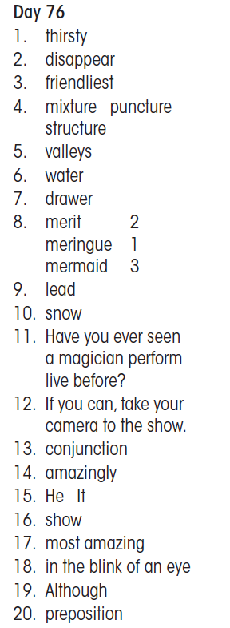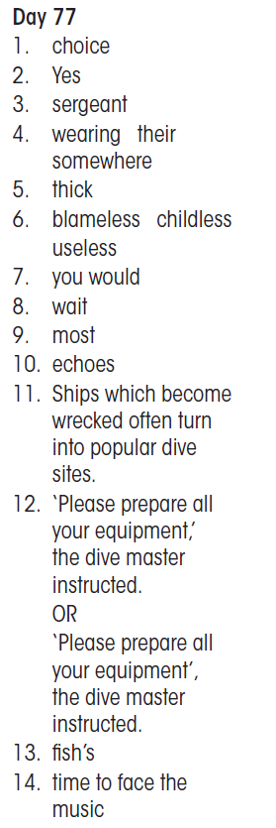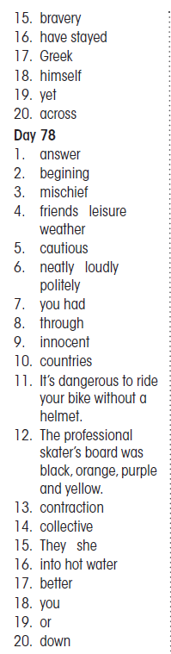

Master Your Maths 5 Answers: Week 23
