Scoil Naomh Eltin Home-School Assignments
Class Level: 5th Class Week Beginning: Tuesday 5th May
Dear students and parents,
We hope everyone is making the most of the fine weather we’re having in the past few weeks and that last week’s learning went OK. It is important that students engage with some form of learning but this may be in the form of baking, working on photography skills, reading their own books or the assignments in this document.
Email Contact
Please continue to share your child’s learning with us. Only parent email accounts are acceptable when it comes to communication. Communication from other emails will not be responded to. Apologies for any inconvenience this may cause but it is in line with GDPR practice for the school.
Padlet Website
We will continue to add new and relevant links to the dedicated padlet website
https://padlet.com/SNE5th2020/xikutk3t4inkesgg
The newest links will appear at the top of each subject column.
What’s new this week?
We have again assigned a new maths chapter this week – the circle. We understand the students’ maths sets are stored in school and unfortunately these cannot be accessed currently. The students only require a compass (instrument for drawing circles) which older siblings might have. They should also be available in the stationary section of the local supermarket or shop. They’re also great for art designs.
Typing.com - This was initiated last week but it is never too late to sign up as all students follow the same typing programme at their own pace. We suggest undertaking one lesson per day starting with the beginner lessons (beginner lesson 1 is “J, F and Space”)
Getepic.com - if you have run out of books to read at home getepic.com is available. This website and app have free ebooks and audiobooks. We have established an educator account. If you would like free access simply email us. Only parent email accounts can be set up. We can share your email with the website until you ask (GDPR).
Don’t forget to stay in touch by email with any queries or updates for us,
Ms O’Sullivan & Mr Murray
Orla.osullivan@scoilnaomheltin.ie Liam.murray@scoilnaomheltin.ie

Typing.com Step-by-Step Guide to “Joining the Typing.com Class”
For parents: Like all the assignments we provide, this is optional. If you believe it will be of benefit to your son/daughter and (possibly more importantly) if you have the laptop, WiFi and time for it then give it a go. The typing course can be completed in approximately 7-8 weeks (taking one lesson per day, using 5-day weeks). Students are free to move as quickly or as slowly through the typing course as they wish but little and often is the best policy we find. Lessons take 10-15 minutes per day. We understand that devices and WiFi are at a premium in homes where parents are working from home online. The lessons could be completed early in the morning or in the evening or when parents are taking breaks from work.

Set up should be completed by parents as it requires consent to be provided to the Typing.com’s Privacy Policy and Terms and Conditions.
When setting up make the website language is set to “UK English” (not US English).
Step 1: Use the link on the Padlet website for Typing.com. This is a unique link to access the “online class”. Here is the link as well - typing.com/join#5E7B8B5BC93AA
Step 2: If a student has a typing.com account already they need only log in using the link in step 1. Alternatively, they can log in to typing.com, go to the “Account Settings” and join another class using the join code “5E7B8B5BC93AA”
If no account has been set up previously click the button to set up a new account and follow the instructions to create a username and password.
Step 3: Once registered, click on “Themes” at the top of the screen and select the background and avatar to suit your student.
Step 4: Once a student registers for the class, we, as administrators, must approve them joining. This may take some time but we will check the account daily.
It is suggested to complete one lesson per day. Don’t worry if you haven’t registered yet. Register when possible and you and your student can follow the lessons from there.
Tips:
- Your daughter/son will need some help initially placing their hands in the correct position on the keyboard. The tutorial will try to highlight this also (right index finger starts on j, left index finger starts on f).
- The course uses audio-visual tutorials to start each lesson so earphones or a headset might be required.
- The eventual goal for 5th class students is to achieve 25 WPM (words per minute) and 92% or higher accuracy. This will take plenty of regular practice however.

May 5th to 8th Optional Challenges
PE | Let’s Get Active  Our very own PE coach, Clare, has made the first in a series of weekly PE lessons on YouTube. The video is 8 minutes long but you’ll have to stop and start the video to complete all the activities.  Could you make your own PE video . . .?
SPHE | SPHE Diary Topic: Sunset v Dusk  Sunset is when the sun goes below the horizon and out of view. Dusk is that time between sunset and nightfall. For some, dusk is seen as a mysterious time, almost magical time, serving as a bridge between the brightness of day and the darkness of night. With your parent’s permission, sit outside and watch as the sky moves from daylight to sunset to dusk to nightfall. Write some words to describe it or draw a picture of your favourite part of the process.
Maths | Manga High 4 May  In April, Scoil Naomh Eltin earned an amazing 1,655 points on Manga High; the 77th highest total in all of the UK and Ireland! In May, our school's goal is to break into the top 50 schools. It’s a tough challenge so we'll need as much help as we can get. It’s going to take teamwork and determination! One Manga High game per day would make a huge difference to our school's total – simply browse the website and choose games from the 5th class section. Will you take on this optional challenge?
Geography | Blue Star Flag - Europe Week to Celebrate Europe Day on May 9th  Senior students have been busy learning about Europe and the EU this school year and would appreciate everyone's help to complete their project. Our challenge is to celebrate Europe Day on May 9th but this can be done anytime between May 5th and May 15th. We know many of you have a special connection to a European country so why not get creative and take a photo of anything in your household linked to that country - traditional dress, traditional food, traditional dance. It’s your choice! Get creative, take a photo and upload using this form. Anything connected to a European country (including Ireland) is acceptable! For your photo to be included simply email a photo to liam.murray@scoilnaomheltin.ie (feel free to include some text about the picture such as the country being celebrated as well as the students involved and the class level they are in).
Art | Don Conroy:  Don Conroy is a famous Irish art teacher who has been teaching children how to draw for decades. Your parents might have heard of him. Take a look at the Padlet website for a link to his website.

Tuesday | Maths: Busy at Maths  This week our topic is The Circle.  - BAM pg 148 – Name the parts of the circle  - Complete Questions 1, 2 and 3  - Exercises on padlet (a) cj fallon (b) ixl practice  English:  - Typing.com - 10 mins per day: next beginner lesson  - New Wave English: Correct Day 85-88 (answers at end of this doc)  - Reading: find something every day to read whether it’s a book, newspaper or online material  Gaeilge:  - 10 mins of Duolingo  - Cúla 4 ar Scoil: TG4 every day at 10.00am  - Bua na Cainte lch 163 – Aonad 1 Ceacht 3 (Also on padlet)  Féach ar lch 163 agus ar an sceideal téilifíse. Look at pg 163, there is a tv guide.  Freagair na ceisteanna ar lch 163(answer Q 1-10) i do choipleabhar.  Tá an chéad cheann déanta duit.

Wednesday | Maths: Busy at Maths  - BAM pg 149 –Drawing Circles  - Question 1  - Watch tutorial on padlet  - If you have a compass have a go at Q2, Q3 and challenges.  English:  - Typing.com - 10 mins per day: next beginner lesson  - New Wave English Day 89  - Reading: find something every day to read whether it’s a book, newspaper or online material  Gaeilge:  - 10 mins of Duolingo  - Cúla 4 ar Scoil: TG4 every day at 10.00am  - Bua na Cainte lch 164 – An clár is fearr leat(Also on padlet)  - Freagair na ceisteanna ar lch 164 i do choipleabhar.  - Listen to reading on padlet.  - We are learning words to describe how the children feel about tv shows. Leadránach - Boring, Greannmhar – Funny, Suimiúil - Interesting, Páistiúil - childish.

Thursday | Maths: Busy at Maths  - BAM pg 150 – Finding the area of a circle.  - Watch tutorial 87 on padlet - very important for today!  - Try Q1- Q4  English:  - Typing.com - 10 mins per day: next beginner lesson  - New Wave English Day 90  - Reading: find something every day to read whether it’s a book, newspaper or online material  Gaeilge:  - 10 mins of Duolingo  - Cúla 4 ar Scoil: TG4 every day at 10.00am  - Séideáin Sí - link on padlet.  - Gutaí - Vowels. Féach ar an físeán ‘Ciseáin na ngutaí’ - watch the video agus bain triail as an cluiche. Click ‘IMIR’.  - We are sorting words that have vowels at the start, middle or at the end.

Friday | Maths:  - BAM pg 151 – Circular designs  - Question 1 and 2. If you have a compass try Q3  English:  - Typing.com - 10 mins per day: next beginner lesson  - New Wave English Day 91  - Reading: find something every day to read whether it’s a book, newspaper or online material  Gaeilge:  - 10 mins of Duolingo  - Cúla 4 ar Scoil: TG4 every day at 10.00am  - Séideáin Sí - link on padlet.  Gutaí le caora. Revise vowels on the video and play the game.  - We are sorting na ngutaí idir caol agus leathan.  Slender/caol = i,e,í,é  Broad/leathan = a,o,u,á,ó,ú

English in Practice 5th Class Answers Day 85-88
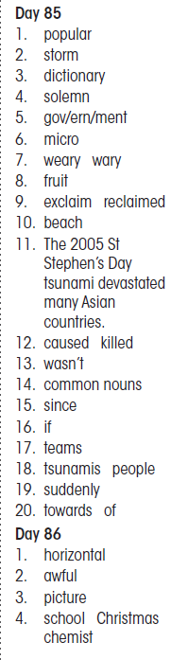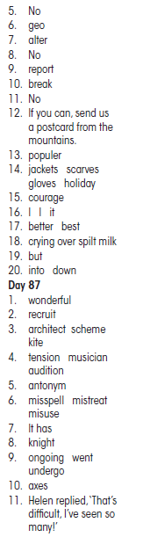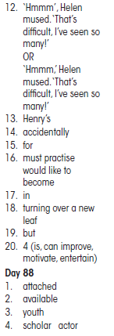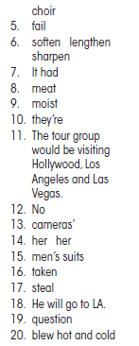

Busy at Maths Answers: Weight
