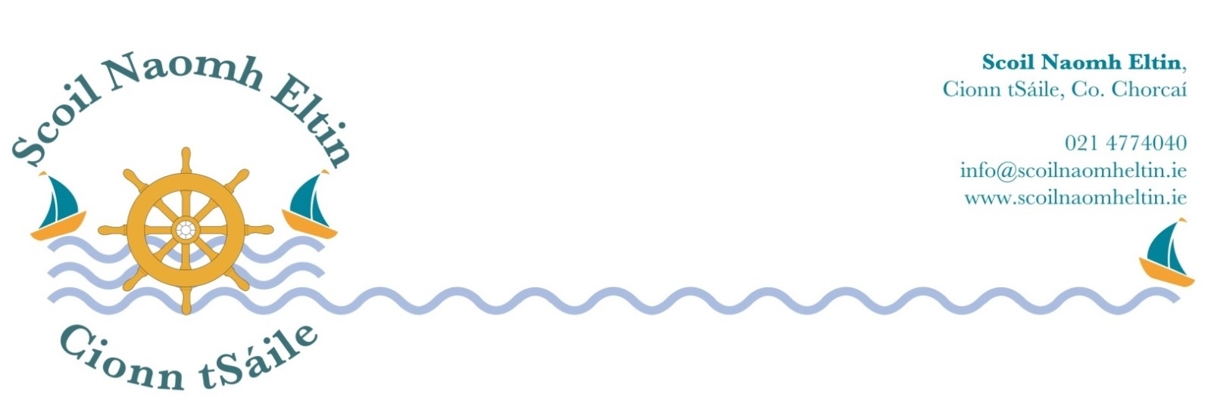

6th Class Booklist
2018 - 2019

Gaeilge: Abair Liom H Folens

English: Word Wise 6 CJ Fallon

Maths: Master your Maths 6 CJ Fallon

Music: Tin Whistle in Key of D

Copies & Folders: Display Folder: 80 Pocket
3 Maths Copies
8 Lined Copies (120 page)
1 X A4 Hardback
1 X scrapbook
2 X A5 Hardbacks

Please have all books and copies covered in clear plastic and clearly labelled on the front covers.

School Equipment:

Pencil Case 1 - a set of markers, colouring pencils, 2 labelled pritt sticks and a child-friendly scissors
Pencil Case 2 - 3 Red pens, 3 Blue Pens, 3 Pencils, Ruler, Eraser and Pencil Sharpener

Maths Equipment:
Maths Set (labelled with name)

The following monies will be collected from each child at the beginning of the school year 2018/2019:

Arts, crafts and photocopying €25.00
Literacy Shared Readers € 3.00
Pupil Personal Accident Insurance € 6.50

Aladdin Connect (School Communication System) € 4.00

Scoil Naomh Eltin Homework Journal € 3.00
(Your child will receive this journal at the start of the school year)

Please use e-payment link which you will receive by text in August.
Otherwise please pay at school office.
If paying by cheque, please make payable to SCOIL NAOMH ELTIN.

