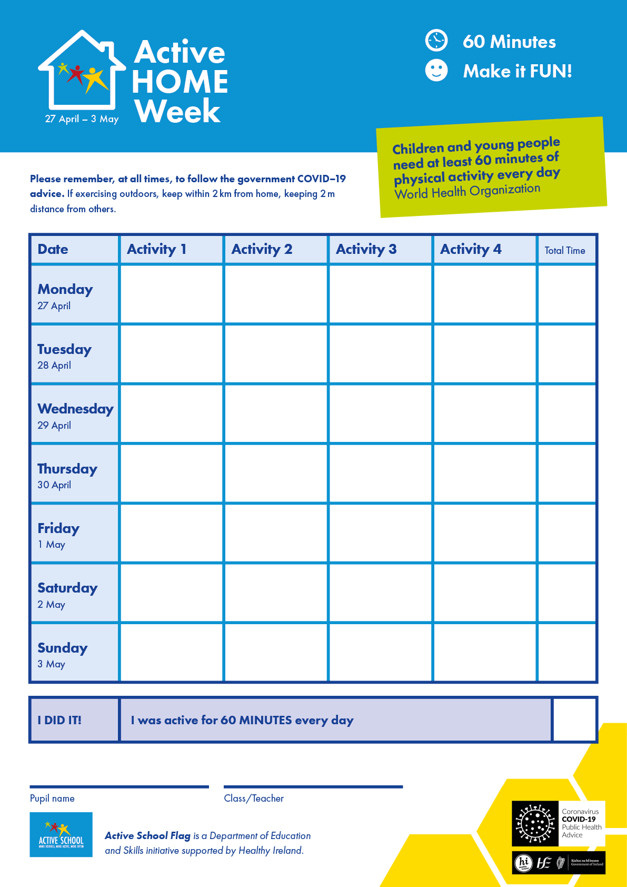

**June 15th to 19th**

B-ball Challenge

B-ball Challenge

B-ball Challenge

B-ball Challenge

B-ball Challenge

B-ball Challenge

B-ball Challenge

B-ball Challenge

B-ball Challenge

B-ball Challenge

B-ball Challenge

B-ball Challenge

B-ball Challenge

| Date | Activity 1 | Activity 2 | Activity 3 | Activity 4 | Activity 5 | Total Time |
| --- | --- | --- | --- | --- | --- | --- |
| Mon | **The Scooter Pillow Race**  [**(click here for video)**](https://www.youtube.com/watch?v=qD51BLS_kwg&app=desktop) | **Cosmic Yoga (**[**click here for video)**](https://youtu.be/5y3gCrL_XIM) | **Football**  **(**[**click here for more information)**](https://www.youtube.com/watch?v=J-B_IBqbxfg&app=desktop) | **Cass CB Fitness**  **(**[**Click here for video**](https://app.seesaw.me/pages/shared_item?item_id=item.21876179-4999-440d-82b6-d8e35232ea4e&share_token=rxK91UNMR1mxAU5CV4iqLA&mode=share)**)** | **Dance with us**  **(**[**Jnr - 1st; click here for video**](https://youtu.be/Pwn4beja1QE)**)**  [**(2nd - 6th; click here for video)**](https://youtu.be/sNog54ovi8Q) |  |
| Tues | **What’s your name challenge**  [**(Click here for more Information)**](https://padlet-uploads.storage.googleapis.com/499949163/197ade8cf0e22a52814a3da59804696e/media.jpeg) | **Cosmic Yoga (**[**click here for video**](https://youtu.be/40SZl84Lr7A)**)** | **Basketball Skills**  **(**[**click here for more information)**](https://www.youtube.com/watch?v=D9jF4lza72I&feature=youtu.be) | **Build a circuit like Daniel**  **(**[**click here for video)**](https://app.seesaw.me/pages/shared_item?item_id=item.07741831-fa2f-4f96-ac80-95d9391e9116&share_token=pEUV9iamSPeGmB-K8q5UXQ&mode=share) | **Dance with us**  **(**[**Jnr - 1st; click here for video)**](https://youtu.be/39L-M5nhx6Y)  **(**[**2nd - 6th; click here for video)**](https://youtu.be/QfzRP6V5rE4) |  |
| Wed | **Basketball Skills**  [**(click here for more information)**](https://www.youtube.com/watch?v=4D6eTEvB2ZY&feature=youtu.be) | **Cosmic Yoga (**[**click here for video**](https://youtu.be/jSZvMHlw9vs)**)** | **Claire’s Athletics**  **(**[**click here for more information)**](http://weplay.ie/) | **Cass CB Fitness (**[**Click here for video**](https://app.seesaw.me/pages/shared_item?item_id=item.81d10e1c-cc02-4a10-8064-0d998e446bcf&share_token=k8mX5Re2TSCX9LQRXzCSQA&mode=share)**)** | **Dance with us**  [**(Jnr - 1st; click here for video)**](https://youtu.be/Imhi98dHa5w)  [**(2nd - 6th; click here for video)**](https://youtu.be/DHscaKsr0IU) |  |
| Thurs | **Outdoor adventures**  **(**[**click here for more information)**](https://www.facebook.com/DCU/videos/2567660333501676/) | **Cosmic Yoga (**[**click here for video**](https://youtu.be/j_3weVPH0-U)**)** | **Soccer skills**  **(**[**click here for more information)**](https://www.youtube.com/watch?v=aCAgQvQ-l6M) | **Build a circuit like Daniel**  **(**[**click here for video)**](https://app.seesaw.me/pages/shared_item?item_id=item.07741831-fa2f-4f96-ac80-95d9391e9116&share_token=pEUV9iamSPeGmB-K8q5UXQ&mode=share) | **Dance with us**  **(**[**Jnr - 1st; click here for video**](https://youtu.be/MAsP7TYPYcc)**)**  **(**[**2nd - 6th; click here for video**](https://youtu.be/nFe4DFC5HiA)**)** |  |
| Fri | **Freestyle Friday**  **(**[**click here for more information)**](https://app.seesaw.me/pages/shared_item?item_id=item.e729293a-75c0-4628-8f72-9f2b38683e98&share_token=8IG2oQg5TYOTJaL5AUk1Kg&mode=share) | **Cosmic Yoga** [**(click here for video**](https://youtu.be/R-BS87NTV5I)**)** | **Lego fitness**  **(**[**click here for instructions)**](https://padlet-uploads.storage.googleapis.com/499949163/ce3acaf9c59cb9ad033a1992f9144596/306A2720_2F81_4B41_BA0E_93BE0BAEDE48.png)  [**(Click here for game)**](https://padlet-uploads.storage.googleapis.com/499949163/ed4867a863f8e366245b0fa5081b2abc/926C233B_6871_4C8D_94C2_0532B2C5C9B4.png) | **Cass CB Fitness (**[**Click here for video**](https://app.seesaw.me/pages/shared_item?item_id=item.315c5b14-5992-4b26-9ddb-90cfbac8523d&share_token=L0U1Qq0HRWS30j79x3It6A&mode=share)**)** | **Dance with us**  **(**[**Jnr - 1st; click here for video**](https://youtu.be/KhfkYzUwYFk)**)**  **(**[**2nd - 6th; click here for video)**](https://youtu.be/Ohga4SS1xOc) |  |

Send your teacher videos and pictures by email!