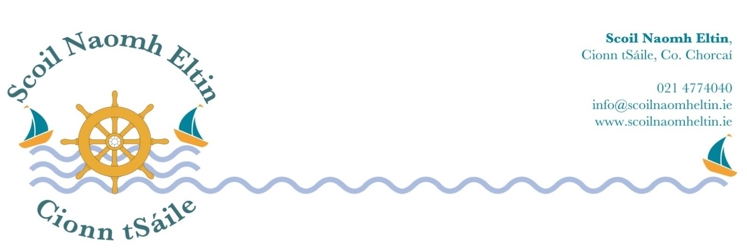

Senior Infant Book Rental – 2018/2019

A Book Rental Scheme is in operation throughout the school. The following is the Book Rental list available to your child’s class. The class teacher will issue a booklist for all other books.
Please use our online payment system or forward this money in a sealed envelope marked with your child’s name to the school office.
Books must be returned at the end of each school year. Lost/damaged books must be paid for.

Full price Rental price
(covered)

Splash € 5.90 € 1.50
The Big Horse € 6.45 € 1.60
What a Mess € 6.45 € 1.60
Stop that dog € 6.45 € 1.60
Total € 25.25 € 6.30

6th Class Book Rental – 2018/2019
A Book Rental Scheme is in operation throughout the school. The following is the Book Rental list available to your child’s class. The class teacher will issue a booklist for all other books.

Please use our online payment system or forward this money in a sealed envelope marked with your child’s name to the school office.
Books must be returned at the end of each school year. Lost/damaged books must be paid for.

Full price Rental price
(covered)

Smart Ice Cream € 18.70 € 4.50
Small World History 6 € 13.25 € 3.00
Small World Geography/Science 6 € 13.25 € 3.00
Philips New Irish Primary Atlas € 14.90 € 3.50
English Dictionary € 10.00 € 2.00
English Thesaurus € 10.00 € 2.00
Busy at Maths 6 € 20.50 € 5.00
Calculator € 1.00
Total € 100.60 € 24.00

1st Class Book Rental – 2018/2019

A Book Rental Scheme is in operation throughout the school. The following is the Book Rental list available to your child’s class. The class teacher will issue a booklist for all other books.
Please use our online payment system or forward this money in a sealed envelope marked with your child’s name to the school office.
Books must be returned at the end of each school year. Lost/damaged books must be paid for.

Full price Rental price
(covered)

Finn’s Dream € 7.70 € 1.90
The Four Friends € 9.05 € 2.20
Small World – 1st Class € 12.10 € 3.00
Total €28.85 € 7.10

2nd Class Book Rental – 2018/2019

A Book Rental Scheme is in operation throughout the school. The following is the Book Rental list available to your child’s class. The class teacher will issue a booklist for all other books.
Please use our online payment system or forward this money in a sealed envelope marked with your child’s name to the school office.
Books must be returned at the end of each school year. Lost/damaged books must be paid for.

Full price Rental price
(covered)
The Grumpy Teaspoon € 11.10 € 2.70

Small World – 2nd Class € 12.10 € 3.00

Total € 23.20 € 5.70

3rd Class Book Rental – 2018/2019

A Book Rental Scheme is in operation throughout the school. The following is the Book Rental list available to your child’s class. The class teacher will issue a booklist for all other books.
Please use our online payment system or forward this money in a sealed envelope marked with your child’s name to the school office.
Books must be returned at the end of each school year. Lost/damaged books must be paid for.

Full price Rental price
(covered)

The Talking Horse € 17.60 € 4.30
Small World History 3 € 12.70 € 3.00
Small World Geography/Science 3 € 12.70 € 3.00
Busy at Maths 3 € 19.30 € 4.70
Calculator € 1.00
Total € 62.30 € 16.00

4th Class Book Rental – 2018/2019
A Book Rental Scheme is in operation throughout the school. The following is the Book Rental list available to your child’s class. The class teacher will issue a booklist for all other books.
Please use our online payment system or forward this money in a sealed envelope marked with your child’s name to the school office.
Books must be returned at the end of each school year. Lost/damaged books must be paid for.

Full price Rental price
(covered)

The Golden Harp € 17.60 € 4.30
Small World History 4 € 12.70 € 3.00
Small World Geography/Science 4 € 12.70 € 3.00
Busy at Maths 4 € 19.30 € 4.70
Calculator € 1.00
Total € 62.30 € 16.00

5th Class Book Rental – 2018/2019
A Book Rental Scheme is in operation throughout the school. The following is the Book Rental list available to your child’s class. The class teacher will issue a booklist for all other books.
Please use our online payment system or forward this money in a sealed envelope marked with your child’s name to the school office.
Books must be returned at the end of each school year. Lost/damaged books must be paid for.

Full price Rental price
(covered)

Call of the Sea € 18.70 € 4.50
Small World History 5 € 13.25 € 3.00
Small World Geography/Science 5 € 13.25 € 3.00
Philips New Irish Primary Atlas € 14.90 € 3.50
English Dictionary € 10.00 € 2.00
English Thesaurus € 10.00 € 2.00
Busy at Maths 5 € 20.50 € 5.00
Calculator € 1.00
Total € 100.60 € 24.00

