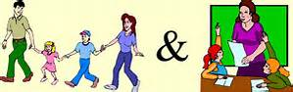
COME AND MEET
NOVEMBER 15-18

Our Parent Association recently advised that it might be a nice idea for parents to see your child’s classroom, where your child sits and to meet with class teachers in class.
You are therefore invited to pop in to visit with your child on the following days.

Tuesday November 15 at 9.20 Senior Infants /First Class
Wednesday November 16 at 9.20 Junior Infant/Second Class
Thursday November 17 at 9.20 Third/Fourth Class
Friday November 18 at 9.20 Fifth/Sixth Class

Looking forward to seeing you
Susan O’ Hanrahan

