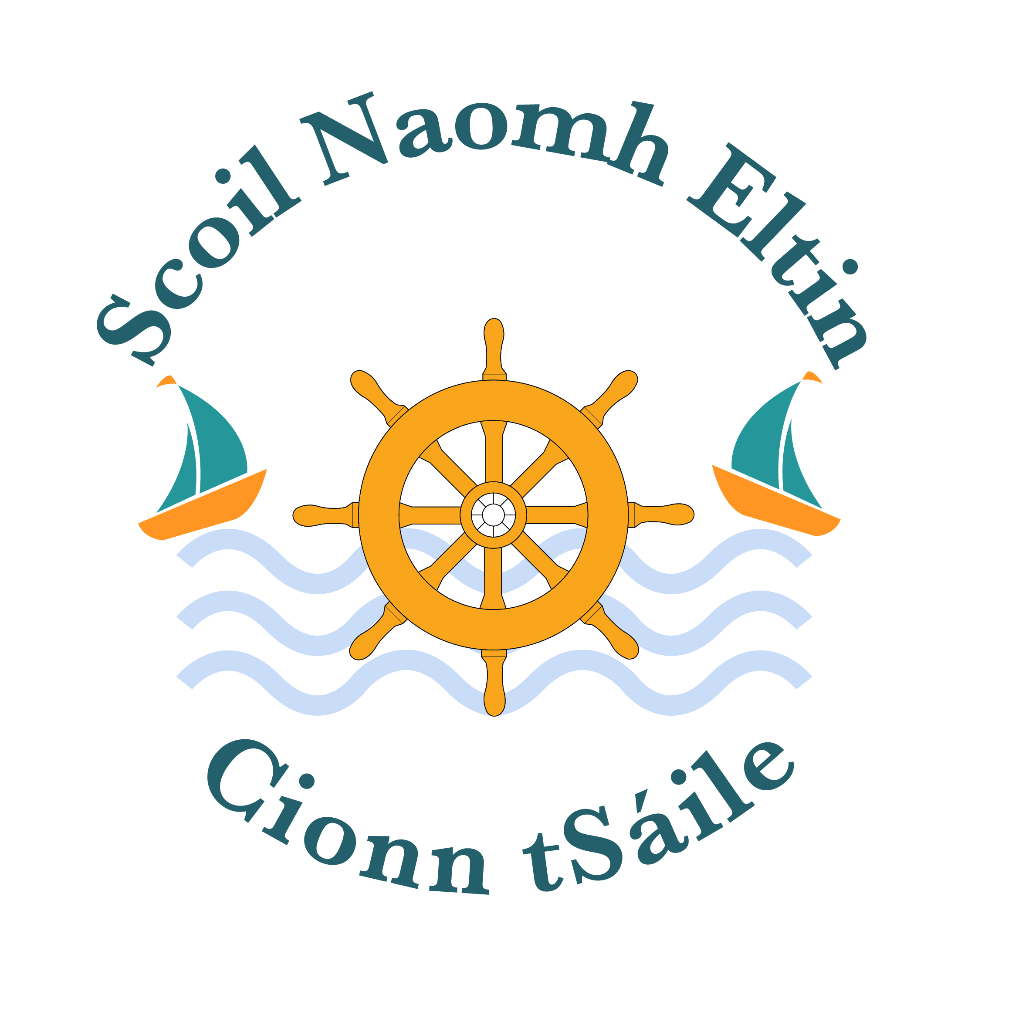
28th September 2016

Parents/Guardians
As part of our Health Promotion School iniative, Cyclone Rep will perform a bullying prevention session for 2nd to 6th class on Thursday 6th October.
The fee payable has been part subsidised by our Parent Association and the H.S.E. Lottery Funding.
The cost per child is now €2.00. A link will be sent to you via text which is payable by Tuesday next, October 4th.
Is mise le meas

____________________
Ms. O’ Driscoll

**P.S. Please note that the confirmed date for First Holy Communion is Saturday May 13th at 11.00 a.m. in St. John the Baptist Church.

