FOXES by Katie Rose Broderick

Foxes are absolutely amazing you would not see them often but when you do, they are amazing and look it to. But people do not know is that foxes are not just wild animals there a lot more than that.
It is like people they have a family; it is not like they spent their life alone. Foxes have families like a pack. The baby foxes wait until a few months until they can be alone. The dad go's out every night and gets food for the babies and the mother stays with the babies until the babies get older and knows how to get their own food and look after themselves.
Foxes are lovely but a lot of people do not like them, but they are harmless they are just lovely living animals.

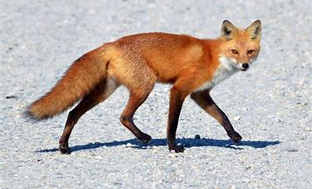
Here is a image of a fox look how lovely he looks, Look at his tale and face.

I hoped you liked it. I have lots of more facts about lots of wild animals.

By Katie-rose Broderick
Foxes

By Katie-Rose broderick

Here are some pictures of foxes outside my backyard
