Scoil Naomh Eltin
Home-School Assignments
Class Level: 6th Class
Week Beginning: Monday 11th May

Dear Parent/Guardian and Students,
I hope you all had a nice weekend and got a chance to enjoy some of the lovely summer sun.
We would like to thank everyone again who has been able to send in work by email. All the work has been fantastic, and for us it has been great to keep in touch with you and your child.
We have outlined activities which you can engage with during the week although we continue to understand some of you may have difficulty with parts of it for a variety of reasons. We would like to reiterate that no one is to feel under pressure to complete the work, all we ask is that you try your best.
If you have questions regarding schoolwork, you can contact us during school hours by email.
jane.thuiller@scoilnaomheltin.ie *Please note different spelling of surname*
micheal.obrien@scoilnaomheltin.ie
Wishing you all the very best,
Ms. Thuillier & Mr. O’Brien

*Please email your work to your teacher’s email address from a parent/guardian’s email only. In line with child protection guidelines we will no longer be able to respond to emails from a student’s personal email address. We thank you for your understanding on this matter.

Answers and Solutions for this week
Please note that the answers/solutions to this week’s work can be found on separate pdf attachments.
- Reading Zone
- Master Your Maths
- Busy at maths
- War Horse text and questions
- War of Independence PDF
***This week’s maths covers a lot of material much of which is quite tricky. Please try to look at the YouTube links before beginning work in your textbook. ***

Monday | Maths:  - Master Your Maths Monday  - Manga High  - Busy at maths page 114- Please try to view Youtube clip  https://www.youtube.com/watch?v=gdo6ENbTPEI video 1  https://www.youtube.com/watch?v=Yxr9B4Mj4a4 video 2  English:  - Reading Zone Continue next story and complete Exercise A  - Read War Horse Chapter 10 (See attached pdf) or listen to Chapter 10 on audio on youtube https://www.youtube.com/watch?v=Lk35LHi8NN8  - Answer chapter 10 Questions.  - Typing activity typing.com/join#5EA2B726A876C  Gaeilge:  - Léigh sa Bhaile Rang a Sé (pg 33 of 120)  - 10 mins of Duolingo per day  - ‘Dán na mbriathra’ poem p. 183 Abair Liom- Translate and learn verse 1. Use pgs. 179-182 to help. See attached image  History:  War of Independence  Watch the following clip https://www.youtube.com/watch?v=itU6dp5tlAc  Read pages 3-5 from War of Independence document  Religion:  You may be familiar with the following hymns. Please listen to both each day so you know the melody and words well. You will find the lyrics on pg 147 of Grow in Love but as usual, the words are part of the video also.  Christ Be Our Light  https://vimeo.com/291514114  Where Your Treasure Is  https://vimeo.com/352889483
Tuesday | Maths:  - Master Your Maths Tuesday  - Manga High  - Busy at maths page 115  (Need a calculator or you can use a phone with the calculator function)  *Please try emailing question 4 page 115*  English:  - Reading Zone Continue next story and complete Exercise B & C  - Read War Horse Chapter 11 (See attached pdf) or listen to Chapter 11 on audio on youtube https://www.youtube.com/watch?v=1MDBHQHSHQ8&t=1s  - Create a comic strip- See attachment at the end of this document  - Typing activity typing.com/join#5EA2B726A876C  *Please try emailing your comic strip*  Gaeilge:  - Léigh sa Bhaile Rang a Sé (pg 34 of 120)  - 10 mins of Duolingo per day  - ‘Dán na mbriathra’ poem p. 183 Abair Liom- Translate and learn verse 2. Use pgs. 179-182 to help. See attached image  Religion:  Please listen to both hymns each day so you become familiar with the melody and the lyrics.  Christ Be Our Light  https://vimeo.com/291514114  Where Your Treasure Is  https://vimeo.com/352889483  History: War of Independence  Read pages 6-9 from War of Independence document  Make a note of 5 interesting facts
Wednesday | Maths:  - Master Your Maths Wednesday  - Manga High  - Busy at maths pg. 116  https://youtu.be/zqJxxSIIo-c Video 3  https://youtu.be/XgYguIxjCjs Video 4  *Please try emailing question 2 and 3 page 116*  English:  - Reading Zone Continue next story and complete Exercise D  - Read War Horse Chapter 12 (See attached pdf) or listen to Chapter 12 on audio on youtube https://www.youtube.com/watch?v=IrUFmoeNWA4  - Answer chapter 12 Questions.  - Typing activity typing.com/join#5EA2B726A876C  Gaeilge:  - Léigh sa Bhaile (pg 35 of 120)  - 10 mins of Duolingo per day  - ‘Dán na mbriathra’ poem page 183 Abair Liom- Translate and learn verse 3. Use pgs. 179-182 to help. See attached image  Religion:  Please listen to both hymns each day so you become familiar with the melody and the lyrics.  Christ Be Our Light  https://vimeo.com/291514114  Where Your Treasure Is  https://vimeo.com/352889483  History: War of Independence  Read pages 10-13 from War of Independence document  Make a note of 5 interesting facts
Thursday | Maths:  - Master Your Maths Thursday  - Manga High  - Busy at maths page 117- Need a calculator  English:  - Reading Zone Continue next story and complete Exercise E  - Read War Horse Chapter 13 (See attached pdf) or listen to Chapter 13 on audio on youtube https://www.youtube.com/watch?v=0JsUOygaPCo  - Answer chapter 13 Questions.  - Typing activity typing.com/join#5EA2B726A876C  Gaeilge:  - Léigh sa Bhaile (pg 36 of 120)  - 10 mins of Duolingo per day  - ‘Dán na mbriathra’ poem page 183 Abair Liom- Translate and learn verse 4. Use pgs. 179-182 to help. See attached image  Religion:  Please listen to both hymns each day so you become familiar with the melody and the lyrics.  Christ Be Our Light  https://vimeo.com/291514114  Where Your Treasure Is  https://vimeo.com/352889483  History: War of Independence  Read pages 14 to 15  What were the four key things you learned about the war of Independence.  Yearbook: Start your Yearbook profile see document attached.
Friday | Maths:  - Master Your Maths Friday Test  - Manga High  - Busy at maths page 118  https://youtu.be/MgFeC1EPw0o Video 5  https://youtu.be/hkCGSKsSrYw Video 6  *Please try emailing question 1 page 118*  English:  - Read War Horse Chapter 14 (See attached pdf) or listen to Chapter 14 on audio on youtube https://www.youtube.com/watch?v=3zZehSzXmS4  - Typing activity typing.com/join#5EA2B726A876C  Gaeilge:  - Léigh sa Bhaile (pg 37 of 120)  - 10 mins of Duolingo per day  - ‘Dán na mbriathra’ poem page 183 Abair Liom- Revise all verses  Religion:  Yearbook: Start your Yearbook profile see document attached.  Please try and email your yearbook profile  (It can be a photo of a page you have written it on or typed)

How to access online resources:
Typing.com Step-by-Step Guide to “Joining the Typing.com Class” | For parents: Like all the assignments we provide, this is optional. If you believe it will be of benefit to your son/daughter and (possibly more importantly) if you have the laptop, WiFi and time for it then give it a go. The typing course can be completed in approximately 7-8 weeks (taking one lesson per day, using 5-day weeks). Students are free to move as quickly or as slowly through the typing course as they wish but little and often is the best policy we find. Lessons take 10-15 minutes per day.  Set up should be completed by parents as it requires consent to be provided to the Typing.com’s Privacy Policy and Terms and Conditions.  When setting up make the website language is set to “UK English” (not US English).  Step 1: Use the link on the Padlet website for Typing.com. This is a unique link to access the “online class”. Here is the link as well - typing.com/join#5EA2B726A876C  Step 2: If a student has a typing.com account already they need only log in using the link in step 1. Alternatively, they can log in to typing.com, go to the “Account Settings” and join another class using the join code “5E7B8B5BC93AA”  If no account has been set up previously click the button to set up a new account and follow the instructions to create a username and password.  Step 3: Once registered, click on “Themes” at the top of the screen and select the background and avatar to suit your child.  Step 4: Once a student registers for the class, we, as administrators, must approve them joining. This may take some time but we will check the account daily.  Tips:  - Your daughter/son will need some help initially placing their hands in the correct position on the keyboard. The tutorial will try to highlight this also (right index finger starts on j, left index finger starts on f).  The course uses audio-visual tutorials to start each lesson so earphones or a headset might be required.
Manga High | Go to https://www.mangahigh.com/en-gb/ and click the Log In button.  Enter the log in details provided to you last October which were stuck into your Homework Journal (if this has been lost please email jane.thuiller@scoilnaomheltin.ie  micheal.obrien@scoilnaomheltin.ie )  Complete the assigned games before the deadline (the games will require you to try a number of times before you succeed – don't give up!)  Students are free to complete other games in Manga High but one particular challenge will be assigned each day
Duolingo  Suggestion: use earphones or a headset for this as listening is required. | - Go to https://www.duolingo.com/welcome and select “School” and continue  - Next Select “Regular - 10 mins/day”  - Select the “Know Some Irish Already” option and take the “Placement Test” (don’t be discouraged if the placement test only unlocks a small percentage of the course – if it unlocked close to all the course you would be fluent already!)  - Complete the registration by creating a profile (age, name, email account and password required)  - Now everyday students can log in and improve their Irish through challenges. Use the tips button on each course to learn some new words before trying the challenges.
Léigh sa Bhaile  Suggestion: use earphones or a headset for this as listening is required. | - Go on to https://www.cjfallon.ie/  - Click on the ‘important notice’ this will allow free access to online resources.  - In the top left-hand box click on primary>6th Class>Gaeilge>Léigh sa bhaile.  - You will be given a list of resources.  - The online book is the first file.  - Click on the eye icon to view the book and the page as given each day.  - For each day there is also a mp3 file. Your child should listen to the audio and read along with the book. There are translations on each page to help them with any new vocabulary.
Get Epic | - Go to https://www.getepic.com/sign-in  - Click Students and educators  - Enter class code  Mr. O’Brien’s class= rsh5662 and select your account  Mrs Thuillier’s class= izy4232.  - Choose from list of prescribed titles

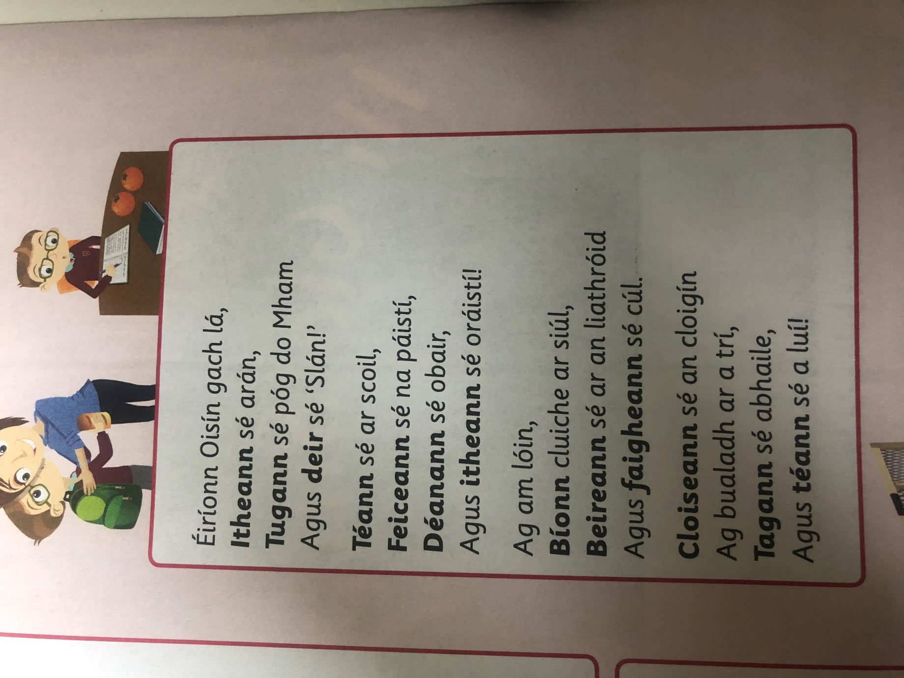

My Profile

Name:

Age:

Hobbies:

Favourite subject:

Favourite food:

Favourite sport:

Best memory from school:

Ambition:
(what I would like to be when I’m older)

