**Scoil Naomh Eltin - Junior Infants**

**25th – 29th May 2020**

Good Morning Parents/Guardians, boys and girls!

I hope you are all well. We have prepared some more work for you to complete at home this week. Please engage with this work as best you can.

You are familiar with the following link which contains online resources for you to use with your child over the coming weeks, this is just an additional aid for junior and senior infants and can be used to supplement learning. I would like to remind you that we will be regularly updating this and adding new ideas for you.

<https://padlet.com/aislingharte/snejnrsnr>

Happy learning!

Kind regards

Hayley Cullinane and Ann Marie Sheehan

**English**

***Sounds Make Words Book:***

Pages to be completed this week: p52, p53, p55, p56

***Tricky words***: You have completed all your tricky words for this year. Well done! Please continue to revise all your tricky words.

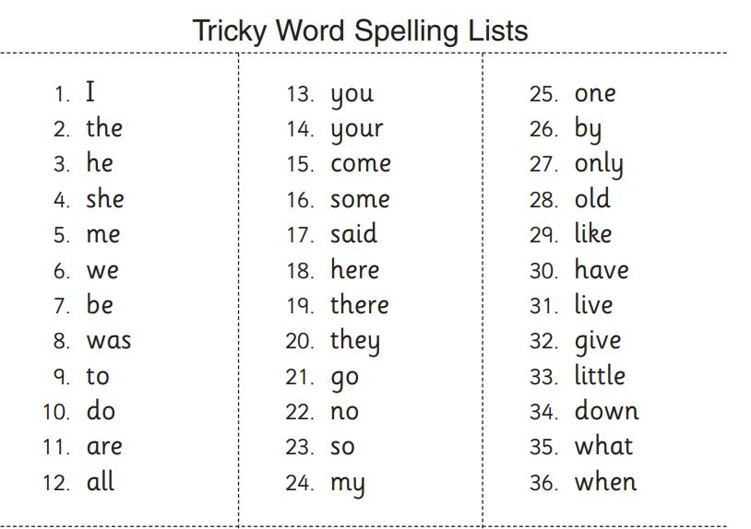

You can now try putting your tricky words into simple sentences both orally and in your lined copybook. The children can choose any tricky word and generate their own sentence. For example:

I have a car.

He was sad.

I like to play.

***Blending list:***

spill

spun

blot

spend

grim

gulp

spell

luck

grit

peck

Encourage your child to sound out each letter and blend the word together. When familiar with the words, you can then call them out and your child can write them independently.

***Reading:***

Please visit and create an account for <https://www.oxfordowl.co.uk/for-home/> (Link also available on padlet). You can sign up to this free as a parent. Each week your child will receive the name of two books to be read at home.

*Books to read this week:*

‘Top Dog’ and ‘Family Poems’

Please use ‘Reading Tips for Junior Infants’ as a guide.

***Handwriting:***

The handwriting workbook used at school is available at: <https://educateplus.ie/homestudy>

Select Primary - Junior Infants - Just Handwriting Pre Cursive

Focus on letters ‘w’ (p58) and ‘x’ (p60) ensuring proper pencil grip and correct letter formation.

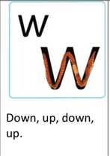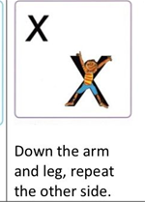

**Oral Language English Lesson:**

<https://www.gillexplore.ie/gill-explore-resources/over-the-moon-junior-infants-skills-book?Chapters=0&ResourceTypes=11535>

Please follow the link above and engage with Unit 9 - Holidays

Here, children can listen to the Oral Language Poster (Story Mode) and answer questions based on the story (Explore Mode).

They can also learn the interactive poem ‘Do you like Summer?’ and engage with the different interactive games in Unit 9.

**My News:**

My News– ask the children to tell you their news orally. What day is it today? What day was it yesterday? What day will it be tomorrow? What is the weather like today? Tell me some news, for example, something you did today/yesterday/tomorrow.

In addition to this, children can write their news in their news copy or the template previously attached. Continue your news writing using ideas below:

Today is Monday.

It is…

A simple piece of their own news such as I like… I had… We went…We saw

When writing it is very important to ensure correct letter formations and to draw children’s attention to tall letters, small letters and fall letters. Please use these documents attached as a guide when writing. Children can draw a picture to represent their news when writing is complete.

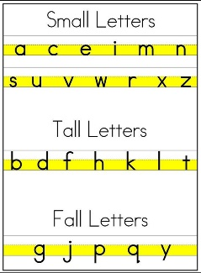 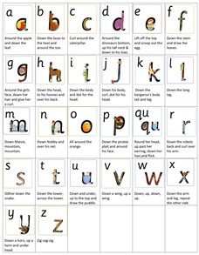

**Maths**

The maths workbook used at school, Busy at Maths is available online at <https://my.cjfallon.ie/dashboard/student-resources>

Select Primary - Junior Infants - Maths - Busy at Maths

***Topic: Money***

Pages: 113, 114, 115, 116

*Please note there is interactive material for every corresponding page available at the CJ Fallon link above.

Mathematical language: 1c, 2c, 3c, 4c, 5c, coin, how many?, count, what colour?, match, join, brown, copper, how much?, buy, cost, price, coins, set, spend, more, less, left

Activity 1:

Hold up a real 1c coin. Ask:

*Can you tell me what this is? What colour is it?*

Have five 1c coins ready on the table and put them one at a time into the child’s hand. Ask how many coins you gave to the child and count them out. Do the same with 2c and 5c coins.

Activity 2:

Place different amounts of money into a box/moneybox including zero up to 5c.

Ask the following type of questions:

* *How many coins are in the moneybox?*
* *If I remove one coin, how much money is left in the moneybox?*
* *If I remove two more coins, how much money is left?*
* *How much money is there if I remove 1c/2c/3c/4c/5c ?*
* *How much money is there if I add 1c/2c/3c/4c/5c ?*

Discussion questions:

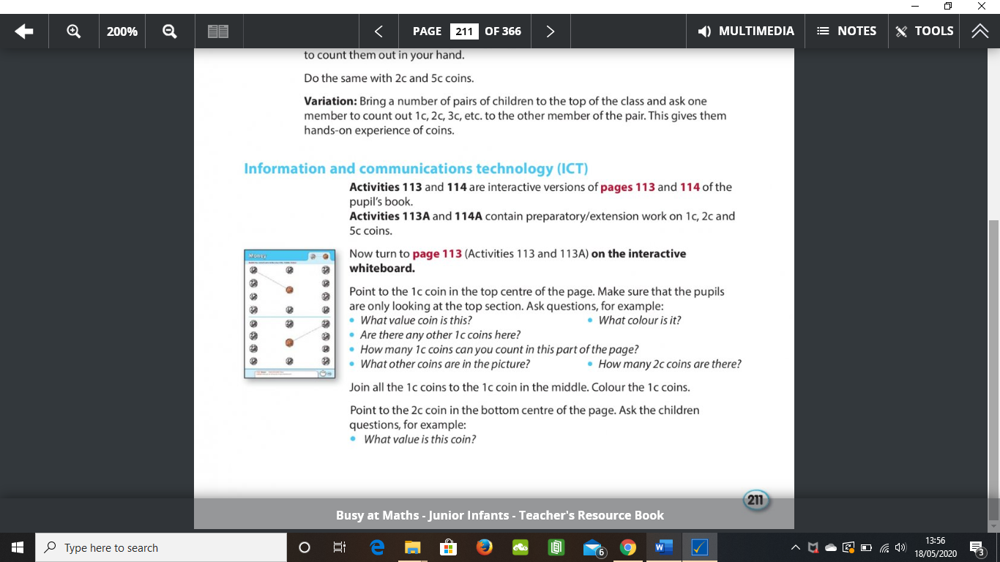

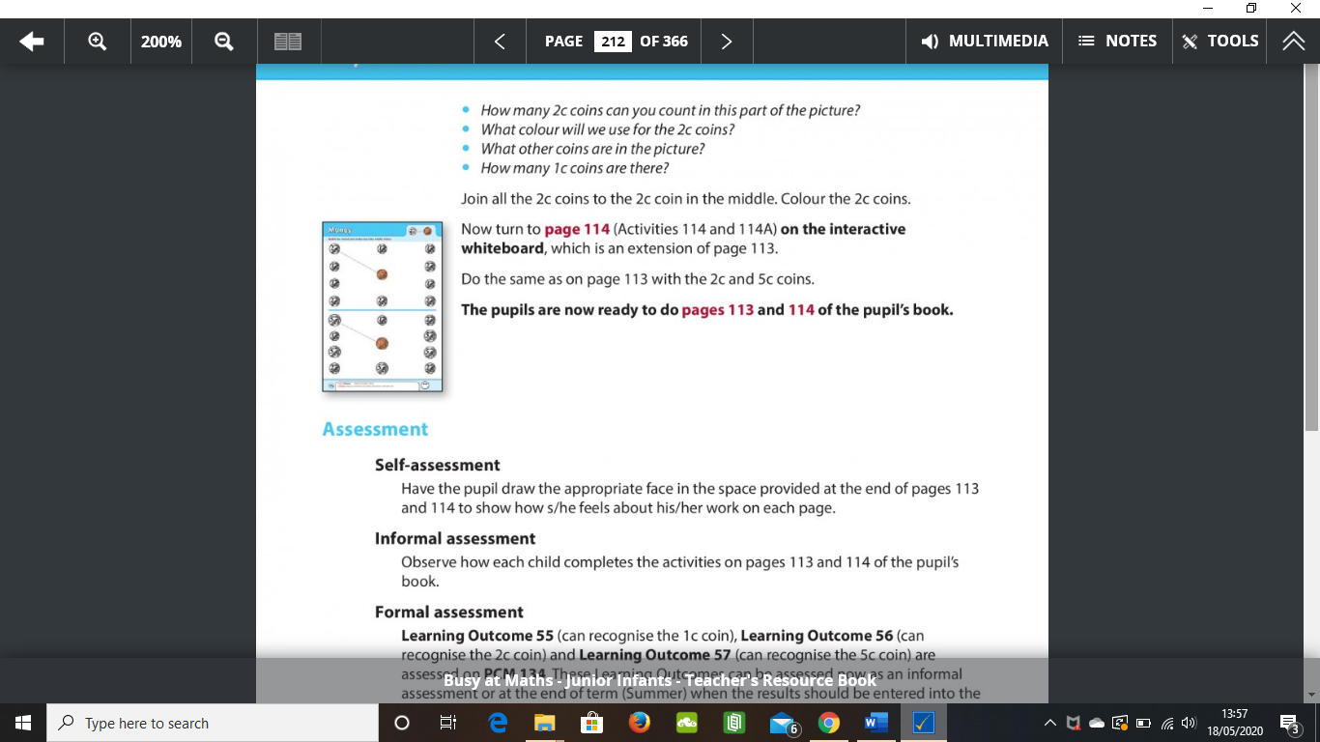

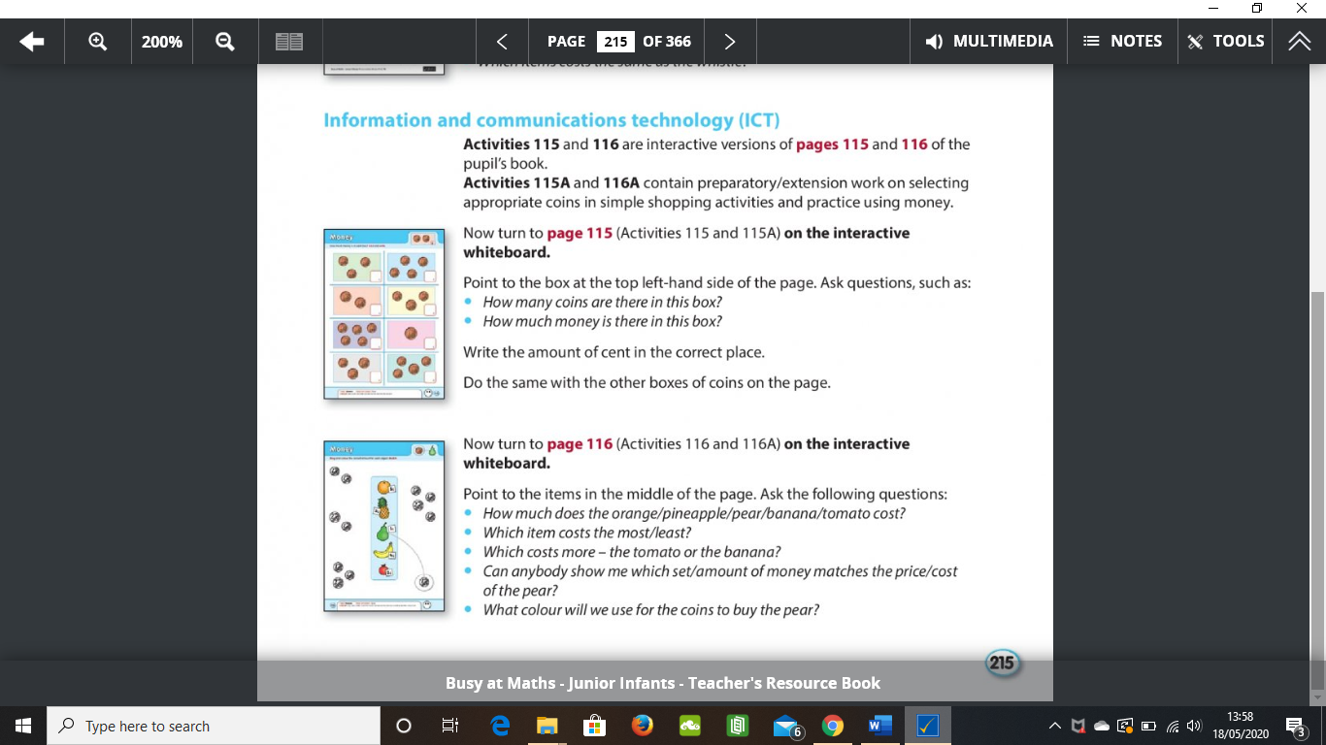

**Gaeilge**

**Theme of the week:** Bosca lóin (lunchbox)

Please use the attached PowerPoint to enable your child to learn the new vocabulary and phrases associated with the theme of their lunch box.

You may also complete the attached activity sheet.

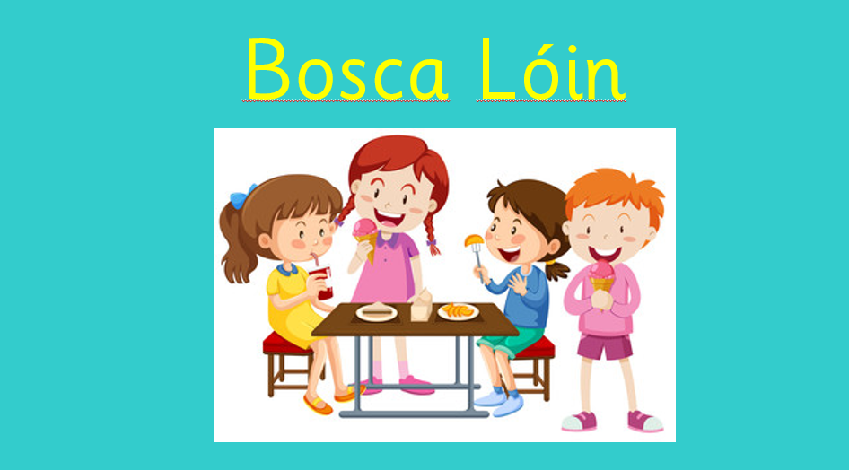

**SESE**

**Theme of the Fortnight: Summer**

This week we will continue to explore the theme of summer.

Teacher has attached worksheets to explore this theme along with the workbook, Explore with me, Junior Infants is available online at <https://www.edcolearning.ie/>

Please use the following details to log in

Username: primaryedcobooks

Password: edco2020

Then select SESE – Explore with me Junior Infants

**Lesson 1 : Summer**

Please go to page 55 of the workbook.

Discuss summer and the changes that occur during summer with your child. Use the link to play the slideshow video. Complete the activity sheet. This can be added to your child’s SESE scrapbook. I have also attached a PowerPoint about summer time.

Additionally, you may like to explore the Summer poster page and oral language activity in this link. <https://www.edcolearning.ie/Book/Page?bookId=book849&chapterId=chapter3&pageId=page22>

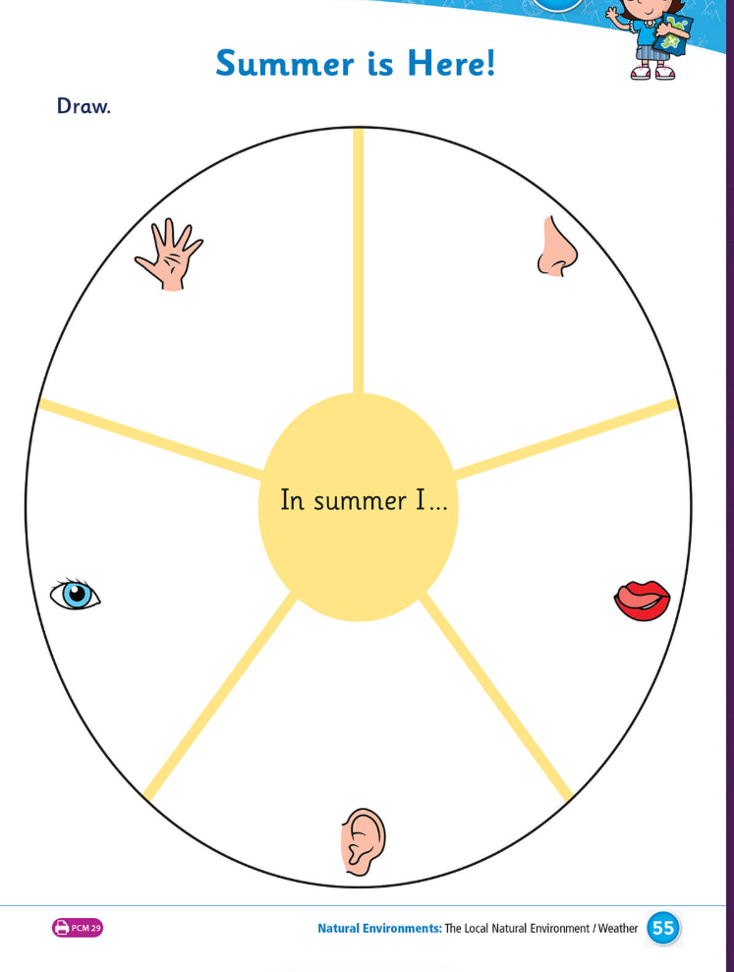

<https://www.edcolearning.ie/Book/Page?bookId=book860&chapterId=chapter12&pageId=page58>

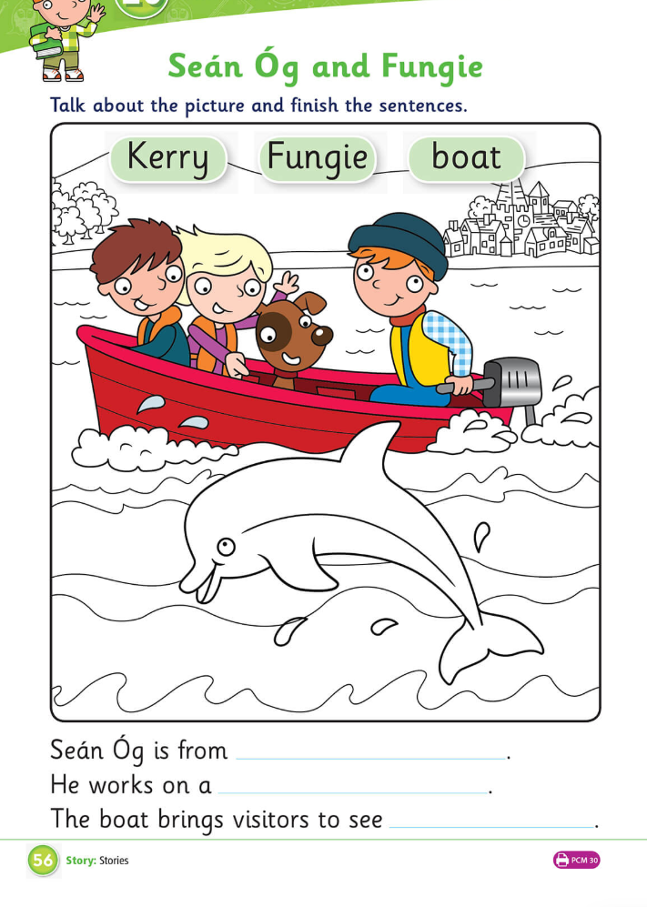

**Lesson 2: Seán Óg agus Fungie**

Please go to page 56 of the activity book. Watch the animation with your child and discuss the story.

Ask your child to complete the activity page by selecting the correct words and colouring the page.

This can be added to your child’s SESE scrapbook.

<https://www.edcolearning.ie/Book/Page?bookId=book860&chapterId=chapter13&pageId=page60>

**Lesson 3: At the Seaside**

Please go to page 57 of the activity book.

Discuss the seaside with your child and items you may find there. Use the link to play the interactive activity.

Complete the attached activity sheet by labelling the seaside items. This can be added to your child’s SESE scrapbook.

Additionally, you could for a walk to the beach with your child to extend their learning.

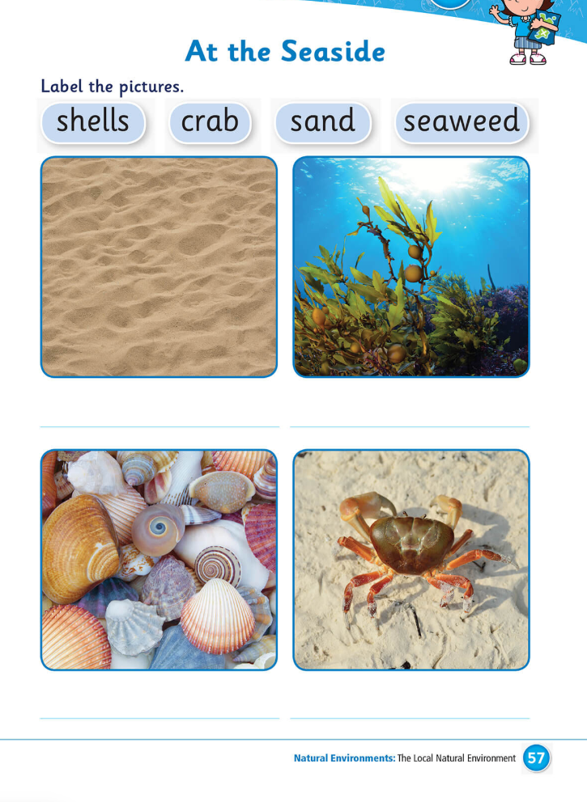

<https://www.edcolearning.ie/Book/Page?bookId=book860&chapterId=chapter13&pageId=page60>

**PE**

Athletics - We Play

Clare Mc Sweeney Scoil Naomh Eltin Athletics Coach has created this week’s video programme for athletics in the home which she has created for our students.

<https://www.youtube.com/channel/UCTBYEvkHmzxQcX2qZoGce5g/videos?view=0&sort=dd&shelf_id=1>

**SPHE**

This week for SPHE we are setting you a challenge! Try to complete one activity a day at home to help your parents/guardians. You can use the activities below or any jobs you are doing at home are perfect. Please let us know what you have been doing via email, voice note or photo. Let’s see how many Junior Infants can complete the challenge! Teacher will then make a slideshow of the photos so you can see what your friends have been getting up to at home**! By sending on a photograph via email you are giving your permission for this photo to be on the school website. Of course, if you do not wish a photo to be published on the school website, then please do not feel under any pressure to send on any - this is optional.**

|  |  |  |  |  |
| --- | --- | --- | --- | --- |
| **Monday**  **Tick one a day** | **Tuesday**  **Tick one a day** | **Wednesday**  **Tick one a day** | **Thursday**  **Tick one a day** | **Friday** |
| Fill/ Empty the Dishwasher or do the dishes | Set the table for dinner | Fill/empty the dishwasher or do the dishes | Set the table for dinner | ***Do something nice for a member of your household*** |
| Vacuum one room in the house | Help an adult put away a basket of laundry | Vacuum one room in the house | Help an adult to put away a basket of laundry |  |
| Clean the bathroom | Clear the table after dinner | Clean the bathroom | Clear the table after dinner |  |
| Clean your bedroom | Sweep the floor | Clean your bedroom | Sweep the floor |  |

**Fine Motor Skills**

This is the rhyme we use in school to encourage proper scissors grip:

Open, shut; Open, shut.

That’s the way we cut, cut, cut

Fingers on the bottom, thumb on top.

Do not let the paper drop.

Open, shut; Open, shut.

That’s the way we cut, cut, cut.

To improve cutting skills this week we could try cutting circle and spiral shapes.

**Spiral Snakes**

You can draw a spiral on paper or print the template included.

Please note for a left handed child, the spiral needs to go the other way!

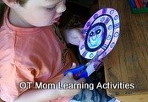

**How to make a "leftie" snake:** Stick the "right hand" snake to a window (so you can see the outline through the paper) and trace the outline on the back of the paper to get a snake with the spiral going the other way.

When you give it to your left handed child, make sure they cut out the spiral on the BACK of the paper.

**Gross Motor Skills**

**Core Strength**

Your child’s core refers to the muscles deep within the abs and back, attaching to the spine or pelvis. Core muscles help keep your child’s body stable and balanced. During these activities, have your child count aloud to ensure they are not holding their breath.

**Egg** Have your child lie on their back with their chin tucked in against their chest and legs raised off the floor at 90 degrees and hands crossed across chest. Encourage your child to hold this position. Gradually increase to 30 – 40 seconds.

**Superman** Have your child lie face down on the floor and lift their head, arms and legs off the floor at the same time. Gradually increase to 30 seconds.

**Crab** Have your child lie face down on the floor and lift their head, arms and legs off the floor at the same time. Gradually increase to 30 seconds.

<https://ncse.ie/wp-content/uploads/2020/03/Gross-Motor-skills-Parent-Booklet-Primary.pdf>