Scoil Naomh Eltin
Home-School Pack
Class Level: 1st Class B
Week Beginning: Monday 30th March

Dear students,
I hope that you are well and that you are following all the advice our government has been giving us. I know it is very hard to not be allowed to go to friend’s houses or have sleepovers, but we must do it to keep everyone healthy and safe. So, enjoy your time spent relaxing and do lots of exercise.
It’s hard to believe now but in years to come there will be 1st Class students just like you reading in their Fun at the Circus or Small World books all about what is happening right now!
Make sure that you are doing your best to be helpful and happy at home and stay safe!
Ms. Dowling

Dear Parent(s)/Guardian(s),
I trust of course, that you are well also. Please note that the following is intended to be a guide and is at your discretion whether to complete tasks/assignments on different days depending on your own circumstances. If there are pages/tasks still to complete from the original home-school pack then please complete these at your own discretion.
Reminder:
- All book companies are offering free access to books online. All you have to do is sign up for free. The following companies are linked with the following books:
- CJ Fallon – Busy at Maths & Small World (SESE)
- Gill Explore – Fun at the Circus (Reader) and Skills book
- Edco Learning – Bua na Cainte
I have included the relevant pages at the end of this week’s plan.

Gaeilge: I will assign tasks in Bua na Cainte again but this week some time spent on Duolingo will also suffice. We will continue to learn about ‘Sa Bhaile’ (home).
Page 60 – Faigh an Abairt. ‘Féach ar an ____’ (Look at the ____).
- Mála (bag) muc (pig)
- Múinteoir (teacher) madra (dog)
- Milseán ( sweet) moncaí ( monkey)
Page 61 – Bí ag léamh. ‘Dathaigh an díon donn’ (Colour the chimney brown)
- An simléar (the chimney) an díon ( the chimney)
- Na fuinneoga (the window) na ballaí (the walls)
- An teach (the house) an doras (the door)

Page 62 – Children can write and draw the answers into their copies.

Maths: We will continue with place value this week in our Busy at Maths Books and also practice counting in 2’s, 5’s and 10’s. Tasks have been assigned in Mental Maths and online on Manga High. The following are warm up activities which may be attempted at any given time in any given week.
Warm up activities- Websites:
- https://www.topmarks.co.uk/maths-games/daily10- This link provides problem solving opportunities for children
- https://mathsframe.co.uk/en/resources/resource/116/telling-the-time - This game is based on time. Children have to identify times on a clock and match them.
- https://www.topmarks.co.uk/learning-to-count/place-value-basketball - Online game based on tens and units.
- https://www.youtube.com/watch?v=g6tJAy_7AL4 Hip Hop Around the Clock - Children can show the times on the clock as they appear in the song or sing the song with their own times.

Literacy:
This week we will be starting a new chapter in your Fun at the Circus named “Spring Picnic Planning”.
As always, before we begin reading the new chapter, look at the title, make predictions, brainstorm and check if you have any connections.
New Vocabulary: There is new vocabulary highlighted on some of the pages. First, we need to explain what the new word means and then we put the new word into a sentence.
- Pg. 45 – challenged, recipes
- Pg. 46 – inspired
- Pg.47 - caterpillar
- Pg. 49 – puncture

Skills Book:
- We must first do our brainstorming page (101) in our Skills Book before we begin to read our new story.
- Page 105 – Phonics (oi, oy words) and grammar (a or an?). Give the tongue twister challenge a go!! You were all brilliant at these in class!
- Page 107 – Procedural writing. We had started looking at how to write a procedure in school – Remember the 3 headings we need to include – Title, what you will need and the steps (we need to take/ follow)
Spelling: This week I want you to pick 6 spellings we have already learned and revise them. Make sure you pick at least two tricky ones to challenge yourself.
https://linktr.ee/gilleducation will bring you directly to the Gill website which is offering free access to online content of the Over the Moon English Scheme.
Extra: These tasks relate to other parts of the Primary Curriculum. SESE, SPHE, Creative Arts and PE are integrated into these tasks.
Children can answer all questions in their copies. Please encourage children to write freely in their copies also.
Kind regards,
D. Dowling
PS: It is important to note that students are eager and motivated to do well at online activities such as those on Manga High. However, it is important to note that these online activities are not intended to be of a competitive nature. Students should view these tasks as a fun method of engaging with their learning and for practice purposes only.

Monday | Maths:  - Mental Maths: Monday  - Manga High: (see login details below)  - Busy at Maths pg. 119  - “Table Wars” Tables Game (kids will know)  English:  - Skills Book: pg. 101 (complete before you start reading new story)  - F at the C – pg. 45  - Spelling (Remember to chose 6 spellings you have learned already and revise)  Gaeilge:  - Sign up to Duolingo (See Below)  - Lch. 60 Bua na Cainte  Extras:  - Jumping Jacks: See how many you can complete in 30 seconds. Try to beat your record!  - Typing.com
Tuesday | Maths:  - Mental Maths Tuesday  - Busy at Maths pg. 120  - Table War  English:  - F at the C: pg. 46  - Reading: DEAR Time (Drop Everything and Read). Chose a book of your own choice.  - Writing: Create your own yard game and write down the instructions of how to play the game  - Spelling  Gaeilge:  - Lch. 61 – Bua na Cainte  Extra:  - Keep a diary in a copybook of you and your family’s experience during our time at home from school. Record your observations, thoughts and feelings each day in your copybook. Be sure to date each diary entry. These will be used to create a class book when we return.  - PE with Joe (Monday to Friday @ 9am YouTube with Joe Wicks)
Wednesday | Maths:  - Mental Maths Wednesday  - Busy at Maths pg. 125  - Table Wars  English:  - Skills Book pg. 105  - F at the C: pg. 47  - Reading: (DEAR Time)  - Spelling  Gaeilge:  - Duolingo  - TG4 – Is Éolaí Mé S1 E1 (Listening)  (https://www.tg4.ie/en/player/online-boxsets/play/?pid=5718302233001&title=Maighn%C3%A9adas&series=Is%20Eola%C3%AD%20M%C3%A9&genre=Cula4&pcode=506062)  Extra:  - Draw a map of the route that you take from home to school. Write step-by-step instructions for an alien (from Planet Kerry) to follow.  - Hurling: Practice roll lifts (if you have a hurley)  - GoNoodle – Guided dance  - Mindfulness: https://app.smilingmind.com.au/ Log on and choose a program.
Thursday | Maths:  - Mental Maths Thursday  - Manga High  - Busy at Maths pg. 126  - Table Wars  English:  1. F at the C: pg. 48  - Reading: Dear Time  - Skills Book: pg. 107  - Spelling  Gaeilge:  - 10 mins of Duolingo per day  - Lch. 62 Bua na Cainte  Extra:  - 10@10 (RTE Junior)  Optional Extra  (This can be completed any day – check the weather!)  Learn about the local area – walk around the local area, investigate where the names of estates/ streets came from. What are the local landmarks or tourist attractions? Record your findings in your copy.
Friday | Maths:  - Mental Maths Friday Review  - Manga High  - Busy at Maths pg. 127  - Table Wars  English:  1. F at the C: pg. 49  - Dear Time  3. Writing: Create a spell that will turn your teacher into a frog. Write a list of ingredients and step by step instructions of how to do so.  Gaeilge:  - 10 mins of Duolingo per day  Extra  Count the number of jumps/hops (1 legged and 2 legged) it takes you to get from a certain place to another eg: living room, garden hallway. Not a race! Challenge yourself to see if you can cover the same distance in less amounts of jumps/hops.

How to access online resources:
Manga High | - Go to https://www.mangahigh.com/en-gb/ and click the Log In button.  - Enter the log in details provided to you last October which were stuck into your Homework Journal (if this has been lost please or if you haven’t received log in details email liam.murray@scoilnaomheltin.ie)  - Complete the assigned games before the deadline (the games will require you to try a number of times before you succeed – don't give up!)  - Students are free to complete other games in Manga High but one particular challenge will be assigned each day
Duolingo  Suggestion: use earphones or a headset for this as listening is required. | - Go to https://www.duolingo.com/welcome and select “School” and continue  - Next Select “Regular - 10 mins/day”  - Select the “Know Some Irish Already” option and take the “Placement Test” (don’t be discouraged if the placement test only unlocks a small percentage of the course – if it unlocked close to all the course you would be fluent already!)  - Complete the registration by creating a profile (age, name, email account and password required)  - Now everyday students can log in and improve their Irish through challenges. Use the tips button on each course to learn some new words before trying the challenges.

Busy at Maths

Fun at the Circus & Skills Book
‘Spring Picnic Planning’

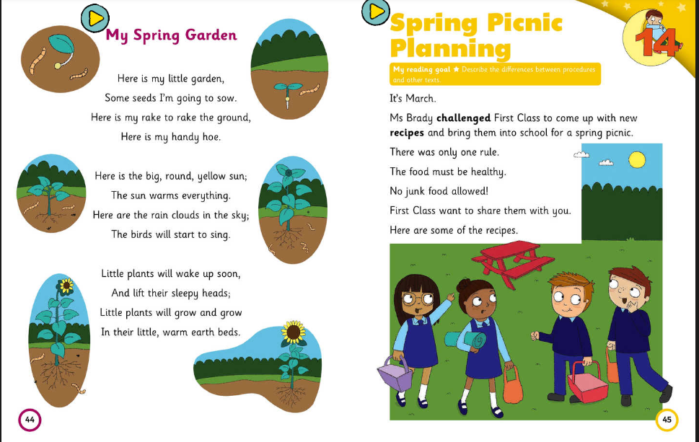

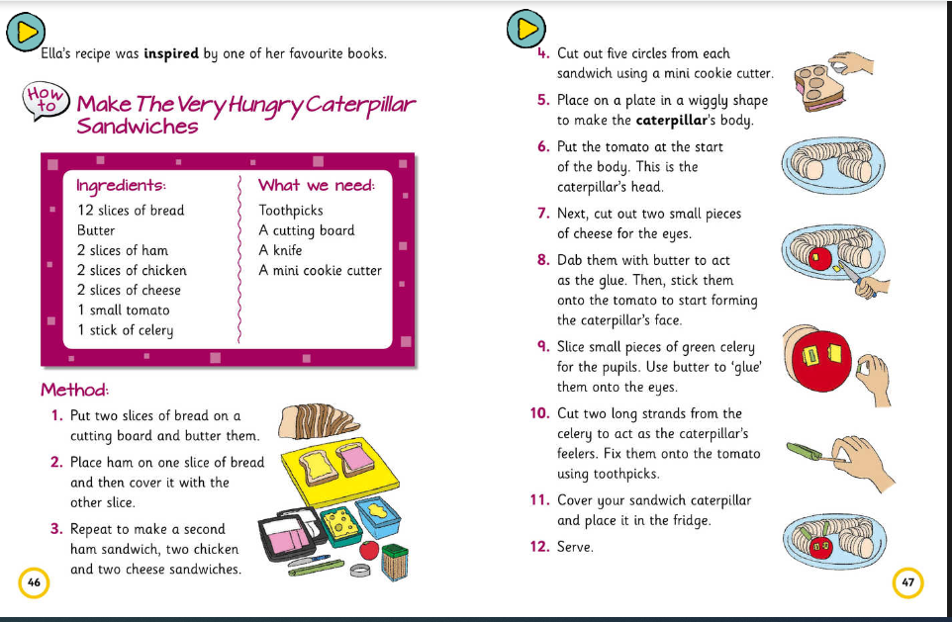
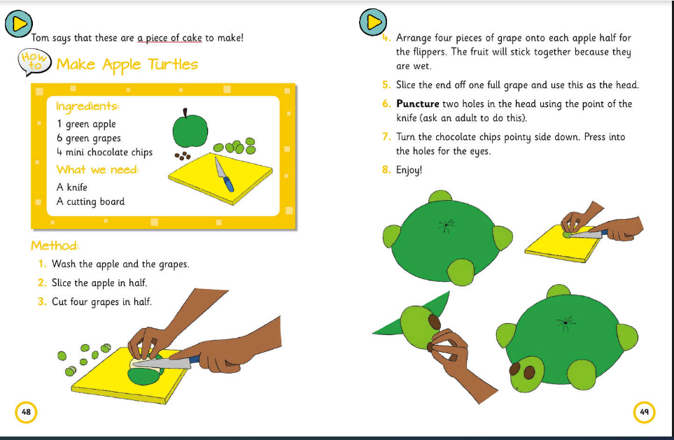

Bua na Cainte:

