Scoil Naomh Eltin
Home-School Assignments
Class Level: 2nd Class A
Week Beginning: Monday 23rd March

Dear students,
I hope that you are well and that you are following all the advice our government has been giving us. I know it is very hard to not be allowed to go to friend’s houses or have sleepovers, but we must do it to keep everyone healthy and safe. So enjoy your time spent relaxing and do lots of exercise- especially hurling!
It’s hard to believe now but in years to come there will be 2nd Class students just like you reading in their Wild Explorers or Small Worlds books all about what is happening right now!
Make sure that you are doing your best to be helpful and happy at home and stay safe!
Mr. O Donovan

Dear Parent(s)/Guardian(s),
I trust of course, that you are well also. Please note that the following is intended to be a guide and is at your discretion whether to complete tasks/assignments on different days depending on your own circumstances. If there are pages/tasks still to complete from the original home-school pack then please complete these at your own discretion.
- All book companies are offering free access to books online. All you have to do is sign up for free. The following companies are linked with the following books:
- CJ Fallon – Busy at Maths & Small World (SESE)
- Gill Explore – The Wild Explorers (Reader) and Skills book
- Edco Learning – Bua na Cainte
I have included the relevant pages at the end of this week’s plan but may not do so next week so I would strongly advise signing up and avail of these resources.

Gaeilge: I will assign tasks in Bua na Cainte next week but for this week some time spent on Duolingo will suffice.

Maths: We will revise subtraction this week in our Busy at Maths Books. Tasks have been assigned in Mental Maths and online on Manga High

Literacy: This weeks work will focus on the chapter in your Wild Explorers named “The ‘How-To’ Guide to Being Eight”. You should find this very easy!!! I know a couple of you aren’t eight yet, but you’re nearly there so give it your best shot!
As always, before we begin reading the new chapter, look at the title, make predictions, brainstorm and check if you have any connections.
https://linktr.ee/gilleducation will bring you directly to the Gill website which is offering free access to online content of the Over the Moon English Scheme.
Extra: These tasks relate to other parts of the Primary Curriculum. SESE, SPHE, Creative Arts of course PE are integrated into these tasks.
Children can answer all questions in their copies. Please encourage children to write freely in thier copies also.
I have included a PDF copy of an excellent book about Irish Female Sports Stars so that children can read, colour, learn and aspire to emulate these heroes!
Kind regards
N. O Donovan
PS: It is important to note that students are eager and motivated (and rightly so) to do well at online activities such as those on Manga High but that I will not be seeing it as a competition amongst students so they should not feel any potential added pressure.

Monday | Maths:  - Mental Maths: Monday  - Manga High: (see login details below)  - Busy at Maths pg 110  - “Shoot the Sheriff” Tables Game (kids will know!!)  English:  - W.E pg 107. Skills Book pg 107  - Reading: 10 mins Drop Everything And Read (DEAR Time) time of book of their own choice.  - Writing: Create your own yard game and write down the instructions of how you play the game  Gaeilge:  - Sign up to Duolingo  Extras:  - Hurling: Practice your roll lift to see how many you can complete in 30 seconds  - “Flower” by Moby – Squat Challenge
Tuesday | Maths:  - Mental Maths Tuesday  - Manga High  - Busy at Maths pg 138  - Shoot the Sheriff  English:  - WE pg 110 and 111  - Reading: DEAR Time  - Writing: 5 Sentences that each include a “silly saying” (kids will know!) that we have learned this year.  Gaeilge:  - 10 mins of Duolingo.  Extra:  - Keep a diary in a copybook of you and your family’s experience during our time at home from school. Record your observations, thoughts and feelings each day in your copybook. Be sure to date each diary entry. These will be used to create a class book when we return.  - Basketball: Practice your dribbling - (no double dribbles!!)  - Hurling: How many roll lifts in 30 seconds – beat your record!  - Typing.com
Wednesday | Maths:  - Mental Maths Wednesday  - Manga High  - Busy at Maths pg 153  - Shoot the Sheriff  English:  1. WE pg 112. Skills Book pg 105  - Reading: (DEAR Time)  - Chose some words from your book – challenge a sibling/parent to spell them and ask them to challenge you with some other words.  Gaeilge:  - Duolingo  - TG4 – Is Éolaí Mé S1 E1 (Listening)  (https://www.tg4.ie/en/player/online-boxsets/play/?pid=5718302233001&title=Maighn%C3%A9adas&series=Is%20Eola%C3%AD%20M%C3%A9&genre=Cula4&pcode=506062)  Extra:  - Draw a map of the route that you take from home to school. Write step-by-step instructions for an alien (from Planet Kilbrittain) to follow.  - Hurling: Roll lifts  - Soccer: “Keepy Uppies” how many can you do?  - Mindfulness: https://app.smilingmind.com.au/ Log on and choose a program. (Children will have used this in classroom/with Mr. O Leary so will be reasonably familiar)
Thursday | Maths:  - Mental Maths Thursday  - Manga High  - Shoot the Sheriff  English:  1. WE pg 113 & 114.  - Reading: Dear Time  2. Creative Writing. Narrative/Story - At summer camp, the boys and girls wage a prank war against one another.  Gaeilge:  - 10 mins of Duolingo per day  Optional Extra  (This can be completed any day – check the weather!)  Learn about the local area – walk around the local area, investigate where the names of estates/ streets came from. What are the local landmarks or tourist attractions? Record your findings in you copy.
Friday | Maths:  - Mental Maths Friday Test  - Manga High  - Shoot the Sheriff  English:  1. WE Revise previous pages. SB pg 102 &103  - Dear Time  2. Create a spell that will turn your teacher into a frog. Write a list of ingredients and step by step instructions of how to do so.  Gaeilge:  - 10 mins of Duolingo per day  Extra  Count the number of jumps/hops (1 legged and 2 legged) it takes you to get from a certain place to another eg: living room, garden hallway. Not a race! Challenge yourself to see if you can cover the same distance in less.

How to access online resources:
Manga High | - Go to https://www.mangahigh.com/en-gb/ and click the Log In button.  - Enter the log in details provided to you last October which were stuck into your Homework Journal (if this has been lost please or if you haven’t received log in details email liam.murray@scoilnaomheltin.ie)  - Complete the assigned games before the deadline (the games will require you to try a number of times before you succeed – don't give up!)  - Students are free to complete other games in Manga High but one particular challenge will be assigned each day
Duolingo  Suggestion: use earphones or a headset for this as listening is required. | - Go to https://www.duolingo.com/welcome and select “School” and continue  - Next Select “Regular - 10 mins/day”  - Select the “Know Some Irish Already” option and take the “Placement Test” (don’t be discouraged if the placement test only unlocks a small percentage of the course – if it unlocked close to all the course you would be fluent already!)  - Complete the registration by creating a profile (age, name, email account and password required)  - Now everyday students can log in and improve their Irish through challenges. Use the tips button on each course to learn some new words before trying the challenges.

Busy at Maths
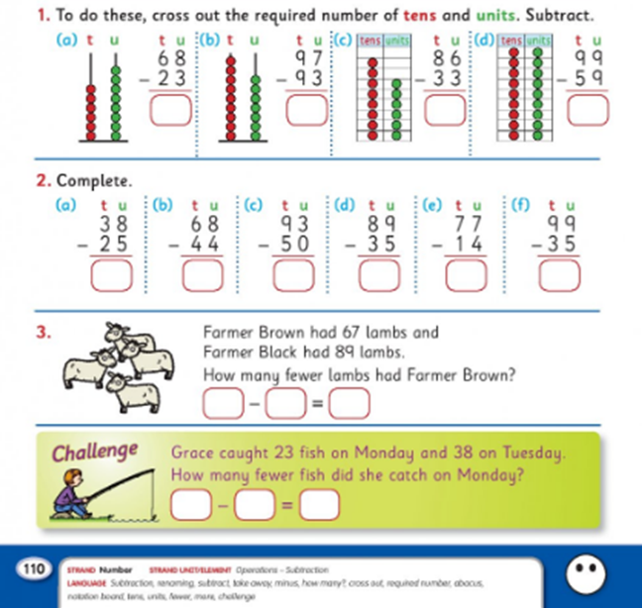
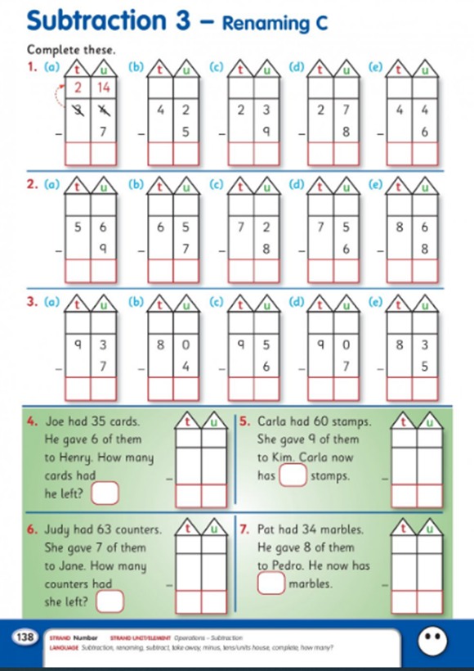
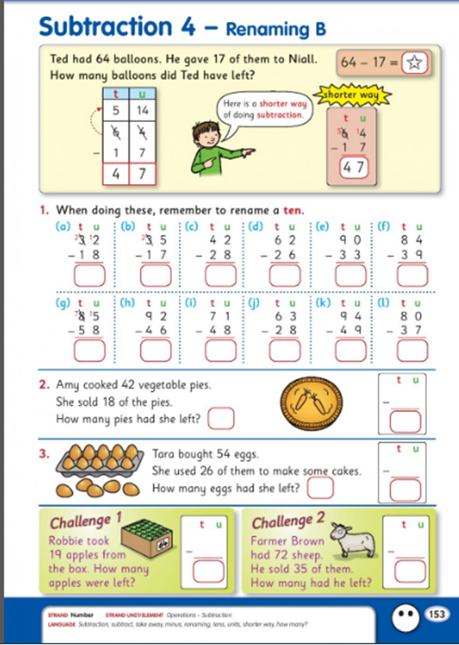

The Wild Explores & Skills Book





