**Senior Infants Work:**



**Week Beginning 18th of May 2020**

18/05/20

Dear Parent/Guardian,

I hope this finds you and all your families well in this unsettling time. The Senior Infants team in Scoil Naomh Eltin hope to continue to provide your children with weekly work which will allow your child access to the Curriculum over the coming weeks. We have provided our email addresses below and would love if this week children sent **either a sample of English or Maths** that they are proud of! Keep an eye on the class page of our school website as we will update it with some of the samples of work we receive. We have created a Padlet activity page which will be regularly updated with both practical and online activities for you to complete with your child if you wish. <https://padlet.com/aislingharte/snejnrsnr>. If you have any queries, please feel free to contact us on the email addresses below. We would be delighted to be of any assistance. And parents remember all you can do is your best!

Ciara.oconnor@scoilnaomheltin.ie Aisling.harte@scoilnaomheltin.ie

Bernie.masterson@scoilnaomheltin.ie

Warmest Regards,

Ciara O’Connor and Aisling Harte

18/05/20

Dear Boys and Girls of Senior Infants,

Ms. O’Connor, Ms. Harte and Ms. Masterson miss ye all so much. We know ye are all being fantastic children for your moms and dads and that ye are remembering to wash your hands regularly! We know that ye are trying your best with your schoolwork and we are super proud of each and every one of ye.

Last week, we were focusing on Yoga/Mindfulness and we hope you enjoyed the activities. We know how hard you are all working from home and thought this week you could use the choice board as a break between work. Below we have attached a choice board with lots of Gross Motor Skills. We would love if ye would pick three tasks a day.

We look forward to seeing all your work.

See ye soon,

Ms. O’Connor, Ms. Harte and Ms. Masterson

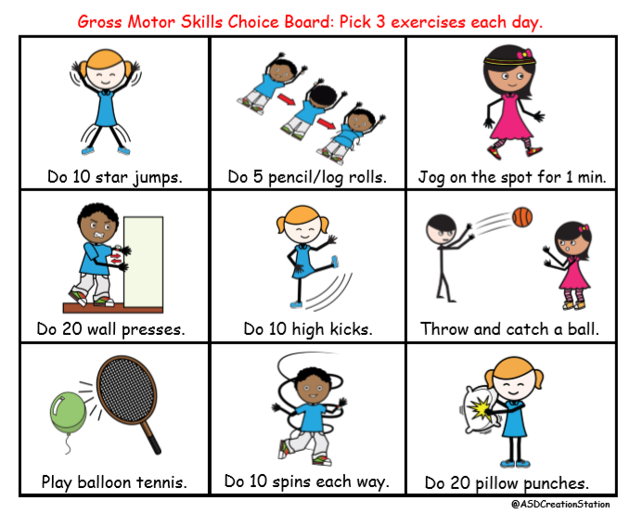

**English**:

As you are aware, we are using Over the Moon as our English Programme. Gill Education have kindly offered free access for parents to their online resources for the duration of school closures. To avail of this resource please visit: <https://www.gillexplore.ie/gill-explore-resources/over-the-moon-senior-infants-skills-book>

**Over the Moon work to be completed:**

1. Based on the Genre Story: Life in the Zoo (available below) the children can create a report on hippos. Pg. 107

<https://content.yudu.com/web/1yssw/0A224cw/OTMSIGS8/html/index.html?origin=reader>

1. **Poetry “The Zoo”:** available at this link - <https://www.gillexplore.ie/gill-explore-resources/over-the-moon-senior-infants-skills-book?Chapters=7661&ResourceTypes=0>

* **Before reading:** You could ask your child if they have ever seen a zoo animal do funny things?; What is your favourite zoo animal?
* **After reading:** Why do you think the monkeys mad them laugh?; Why do you think the elephant is the author’s favourite.

**Visualising:** Read the poem a second time, ask your child to close his/her eyes and think about what pictures they see in their heads as they listen. Discuss these images after.

1. Sequencing of the poem and rhyming words pg. 109
2. Phonics pg. 110

**Additional English work to be completed:**

1. My news (writing) – Today is …. It is …. My news is… - Please encourage children to write independently and to use their phonics to spell words.
2. Reading: <https://www.oxfordowl.co.uk/for-home/>
3. Handwriting: pg. 30 Capital L and pg. 31 Revision <https://educateplus.ie/ppresource/just-handwriting-senior-infants-pre-cursive>
4. **Revise** all sounds and tricky words in word folders. **Learn** the next three tricky words. **If** your child has learned all tricky words please start at revising from the beginning and ask your child to write simple sentences using tricky words. Where possible, parents could give children a little test by selecting tricky words and asking their child to say the word – this will show where revision is needed. (See grid below)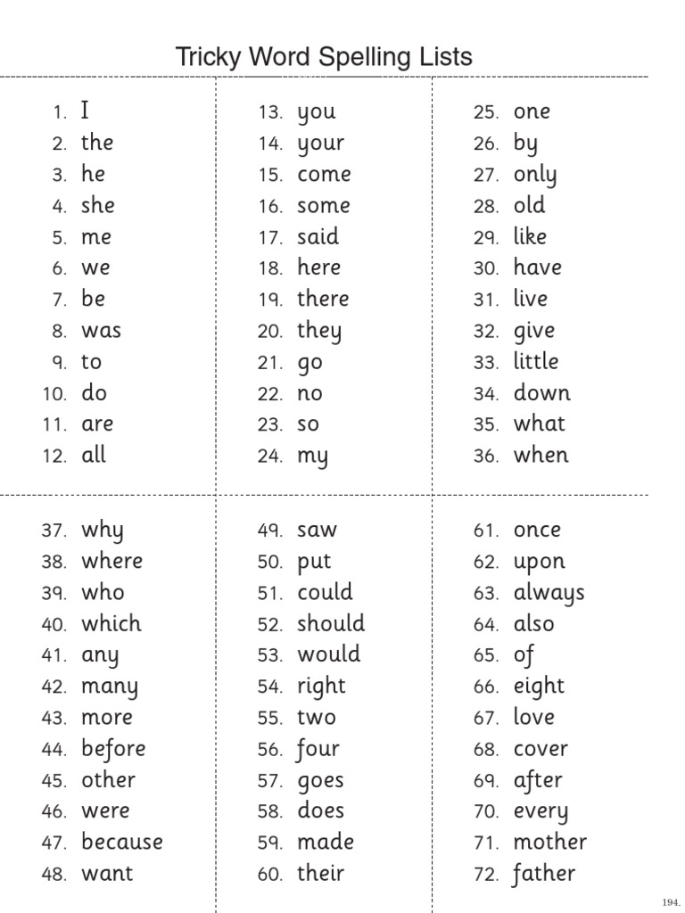
5. Word Families: Create a list of 10 rhyming words. **– ot** e.g. cot, dot, plot etc., **- ub** e.g. cub, stub etc., **­-ug** e.g. slug, bug etc.

**Maths**:

This week we are going to revise the concept of data, introduce the concept of more than/less than and money to the children.

* **Interactive games:**

<http://toytheater.com/fishing/>

<https://pbskids.org/curiousgeorge/busyday/hats/>

<https://pbskids.org/curiousgeorge/busyday/bugs/> (More than/Less than)

1. **Nature Walk**: the children could go on a nature walk/ mini beast hunt and gather data as they go. We have included a sample graph below or feel free to create your own on a blank page or in a copy book.

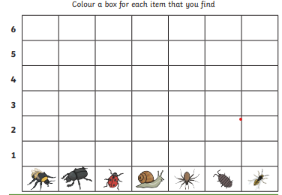

1. Busy at Maths pg. 102 & 103 deal with more than/less than. As a follow on from this you could ask your child to find objects in the house and discuss which group has more and which has less (e.g. red crayons and blue crayons; forks and spoons; 1c and 2c etc)
2. Sorting coins, using either real coins, toy coins or printed/drawings of coins (see below), ask your child to sort coins into groups of 1c, 2c, 5c, 10c and 20c

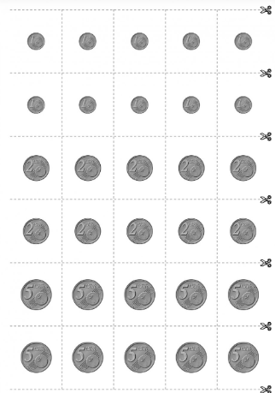

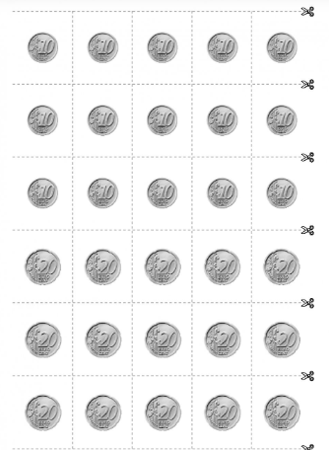

**Gaeilge:**

**TG4 will be broadcasting a new programme called “Ar Scoil” weekdays at 10 a.m. – this will be similar to the RTÉ HomeSchool Hub but will be through Irish**. Our topic is “Lá Breithe” (Birthday). EDCO have kindly given access to the interactive Bua na Cainte programme which can be downloaded using the following steps:

1. Go to [www.edco.ie/bua](http://www.edco.ie/bua)
2. Select the file which suits your computer PC or MAC
3. Select the Class Level you require (Senior Infants), then click on it to start a download of the file
4. Once the download has completed, click on the file to install and follow the on-screen instructions.
5. A Bua na Cainte icon will appear on your desktop. Once you select this icon a login page will open where you will need to enter the details included below

**Login: trial**

**Password: trial**

Once you have accessed Bua na Cainte, **select “Ócáidí Speisialta”** from the themes, **Lá Breithe** and **Ceacht 3** (Lesson 3) and **Ceacht 4** (Lesson 4) **.** There are lovely songs and interactive games which can all be done over the week (Please don’t feel under pressure to complete each game/activity that accompanies each lesson). There is a new song this week which would be a lovely way to begin each lesson, it can be found under the “**Rainn**” tab at the bottom of **Lá Breithe** – please select **Lá Breithe Sona Duit** (Happy Birthday to You)

**Revise:** Asking someone their age – **Cén aois tú?** (How old are you?) **Tá mé ______ bliana d’aois (trí, ceithre, cúig, sé).** I am ______ (three, four, five, six) years old. **Tá mé seacht mbliana d’aois.**  I am seven years old. **Tá ______ (an cat, an chearc, an luch, an coinín, an t-iora rua, an madra) ______ d’aois. (aon bhliain, dhá bhliain, trí bliana, ceithre bliana, cúig bliana, sé bliana)** The ____ (cat, chicken, mouse, rabbit, fox, dog) is _____ year(s) old. (one, two, three, four, five, six)

**Ceacht 4:** Is based on wishing somebody happy birthday and then giving them a present. The next part is asking what is in the present.

**Lá breithe sona duit.** (Happy Birthday to you.)

**Go raibh maith agat.** (Thank you.)

**Seo duit _____. (cárta, bronntanas, cáca)** (Here is a ____. (card, present, cake)

**Go raibh maith agat.** (Thank you.)

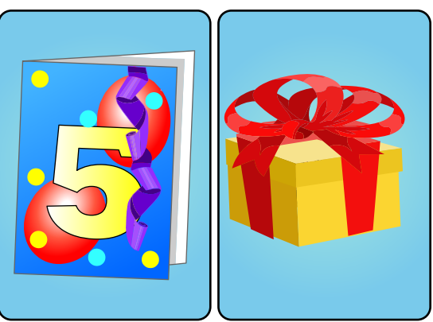 

**Cad atá sa bhronntanas?** (What’s the present?)

**Tá _____ sa bhronntanas. (cluiche, tarracóir, buachaill bó).** (It’s a ___. (game, tractor, cowboy).

**Ceacht 5:**

**An bhfuil ___ sa bhronntanas? (bád, eitleán, bábóg, cluiche, liathróid, tarracóir, buachaill bó, brící)**

Is the present ____? (a boat, an airplane, a doll, a game, a ball, a tractor, a cowboy, blocks)

**Tá ____ sa bhronntanas.** (Yes, it is a ____.)

**Níl ____ sa bhronntanas.** (No, it isn’t a _____.)

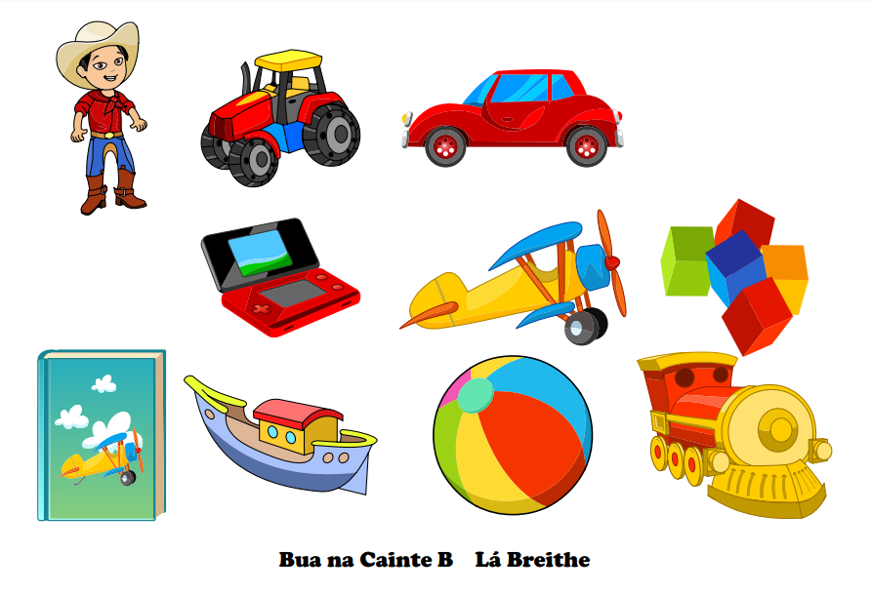

**S.E.S.E: (History, Geography, Science)**

We have outlined the learning objectives for these subjects below. **These activities are covered over a two-week period**.

**History:**

* Listen to, discuss, retell and record through pictures and other simple writing activities some stories from the lives of people who have made a contribution to local and/or national life and to the lives of people in other countries in a variety of ways e.g. The Lighthouse Keeper

To access The Lighthouse Keeper story please register with EDCO online:

1. Go to [www.edcolearning.ie](http://www.edcolearning.ie)
2. Enter username primaryedcobooks and then enter password edco2020
3. Once logged in please copy and paste this link into search bar <https://www.edcolearning.ie/Book/Page?bookId=book853&chapterId=chapter12&pageId=page61>
4. Select animation in top left-hand corner

* **Skills: Thinking like a historian:** What is a lighthouse?; What was Michael’s job?; What did he do?; Why are there no lighthouse keepers anymore? Are there any other jobs that used to be done by people but are now automated? (e.g. level crossings, ticket machines, self-service checkouts)
* **Questions:** the questions on pg. 57 can be completed orally.
* You could also use this as an opportunity to look at the Old Head of Kinsale Lighthouse and learn some facts about it – the children could draw pictures and write some facts in their SESE sketchbooks. If you are lucky enough to live within 5km of the Old Head why not take a walk and look at the signal tour and lighthouse. You could also look at it on Google Maps if going for a walk is not an option.

**Geography:**

* Identify, discuss and implement simple strategies for conserving water.

**Activities:**

1. Discuss the ways we use water every day.
2. Interactive activity available at (use login details above for EDCO): <https://www.edcolearning.ie/Book/Page?bookId=book853&chapterId=chapter12&pageId=page62>
3. Explain to your child that water is a precious resource and we must be mindful not to waste it. Ask your child some ways we might conserve (save) water.
4. Replay the interactive activity above and ask your child is the character is wasting/saving water.
5. SESE sketchbook – write 3 ways that you use water and draw some good habits when using water. (See link above for examples of good and bad habits – these could be a point of discussion also)

**Science:**

* Investigate how forces act on objects – float or sink
* Sort items based on whether they will float or sink

**Activity:**

1. Read: Who Sank the Boat by Pamela Allen <https://www.youtube.com/watch?v=C_cYb9RHKUQ>

Predict who might sink the boat; discuss what happens as each animal gets on the boat;

1. Explain to your child that whether an item floats or sinks depends on its density – how tightly packed together the material inside it is. A boat is very heavy but hollow, so it is not dense and can float. A marble is small and dense so it sinks.
2. The page below can be used as a guide, using your SESE sketchbook or a blank page you can draw the items you test. Remember to guess whether it will float or sink before testing!
3. **Challenge:** How can you make a plastic bottle sink? Try it out!

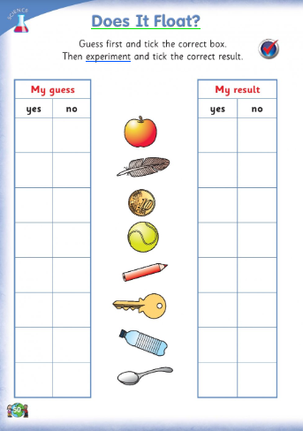

**SPHE:**

My Happiness Journal (see document attached). It is so important to be thankful for all the wonderful and happy moments in our lives, especially at a difficult time like this. We have attached a template of a ‘My Happiness Journal’ you may like to use or you could create your own.

**PE:**

Athletics

Clare McSweeney (Athletics Coach) will be doing weekly “We Play” videos.

<https://www.youtube.com/watch?v=AGpLIPCa4oo&feature=youtu.be>

Challenge: Spell your name! (also available on our class padlet <https://padlet.com/aislingharte/snejnrsnr>)

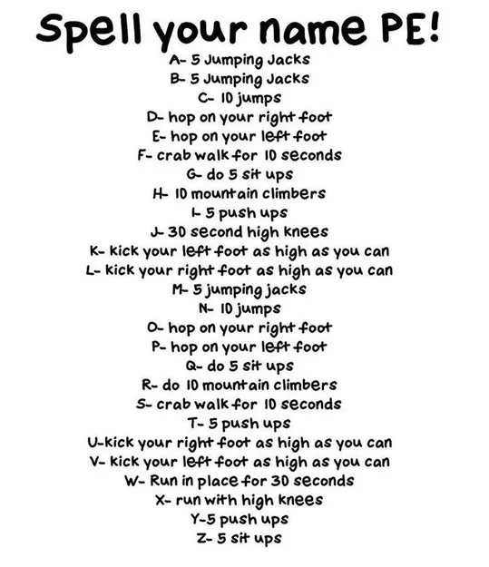

**Arts Education (Drama, Music, Art):**

**Music:**

**Listening and Responding**

Carnival of the Animals <https://www.youtube.com/watch?v=1L993HNAa8M>

* Ask your child to listen to some/all sections of this piece.
* Encourage them to draw the animals they hear or they think match the music.

**Art:**

Draw with Don (YouTube)

**Lesson:** Draw a Tiger

<https://www.youtube.com/watch?v=k1YV_Y6dQUk>

**Drama:**

Using the music from music, Carnival of the Animals, become aware of shape and space in drama by using their body and other objects to express the music.

Examples: The march of the Lion (making themselves big and marching)

Tortoises (low to the ground and slow)