**Senior Infants Work:**



**Week Beginning 25th of May 2020**

25/05/20

Dear Parent/Guardian,

I hope this finds you and all your families well in this unsettling time. The Senior Infants team in Scoil Naomh Eltin hope to continue to provide your children with weekly work which will allow your child access to the Curriculum over the coming weeks. We have provided our email addresses below and would love if this week children sent **either a sample of English or Maths** that they are proud of! Keep an eye on the class page of our school website as we will update it with some of the samples of work we receive. We have created a Padlet activity page which will be regularly updated with both practical and online activities for you to complete with your child if you wish. <https://padlet.com/aislingharte/snejnrsnr>. If you have any queries, please feel free to contact us on the email addresses below. We would be delighted to be of any assistance. And parents remember all you can do is your best!

Ciara.oconnor@scoilnaomheltin.ie Aisling.harte@scoilnaomheltin.ie

Bernie.masterson@scoilnaomheltin.ie

Warmest Regards,

Ciara O’Connor and Aisling Harte

25/05/20

Dear Boys and Girls of Senior Infants,

Ms. O’Connor, Ms. Harte and Ms. Masterson miss ye all so much. We know ye are all being fantastic children for your moms and dads and that ye are remembering to wash your hands regularly! We know that ye are trying your best with your schoolwork and we are super proud of each and every one of ye.

We hope you enjoyed the Gross Motor activities last week. This week we are back to making a special effort to help moms and dads around the house and learning to do things for yourself. This is called being independent which is really important! Below we have attached a choice board with lots of little jobs. We would love if ye would pick three jobs a day. I know your moms and dads would really appreciate it.

We look forward to seeing all your work.

See ye soon,

Ms. O’Connor, Ms. Harte and Ms. Masterson

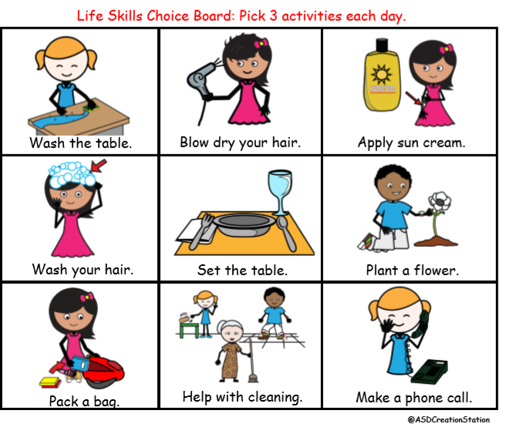

**English**:

As you are aware, we are using Over the Moon as our English Programme. Gill Education have kindly offered free access for parents to their online resources for the duration of school closures. To avail of this resource please visit: <https://www.gillexplore.ie/gill-explore-resources/over-the-moon-senior-infants-skills-book>

**Over the Moon work to be completed:**

1. Fiction Reader; Adventures in the Zoo <https://content.yudu.com/web/1yssw/0A224cw/OTMSnrInfsFReader8/html/index.html?refUrl=https%253A%252F%252Fwww.gillexplore.ie%252Fgill-explore-resources%252Fover-the-moon-senior-infants-skills-book%253FChapters%253D7661%2526ResourceTypes%253D11302>

* **Before reading**; Discuss the title and the front cover of the book. Ask the children to make predictions about the story.
* **After reading:** Ask the children to tell you about their favourite animal and why.

1. The children can fill the fact file below choosing an animal from the reader. They can find all the information from the reader.

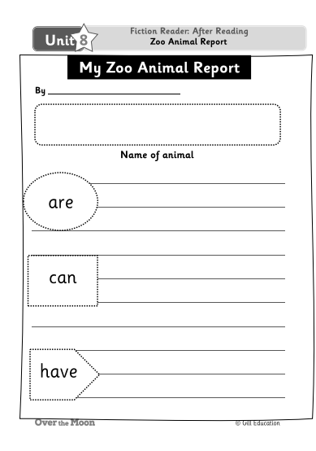

1. Grammar Capital letter and full stops P.112
2. Phonologic Awareness p.113

**Additional English work to be completed:**

1. My news (writing) – Today is …. It is …. My news is… - Please encourage children to write independently and to use their phonics to spell words.
2. Reading: <https://www.oxfordowl.co.uk/for-home/>
3. Handwriting: pg. 32 revision, p 33 and 34
4. **Revise** all sounds and tricky words in word folders. **Learn** the next three tricky words. **If** your child has learned all tricky words please start at revising from the beginning and ask your child to write simple sentences using tricky words. Where possible, parents could give children a little test by selecting tricky words and asking their child to say the word – this will show where revision is needed. (See grid below)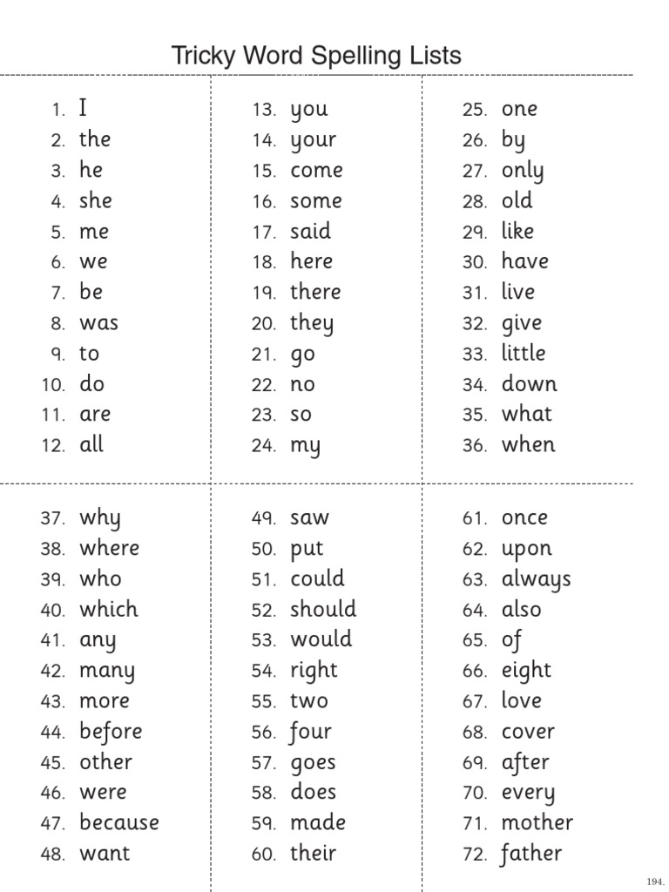
5. Word Families: Create a list of 10 rhyming words. **–un** e.g. fun, sun **-ut** e.g. shut, nut

**Maths**:

This week we are going to continue with the concept of money. This is a very important chapter for the children to comprehend.

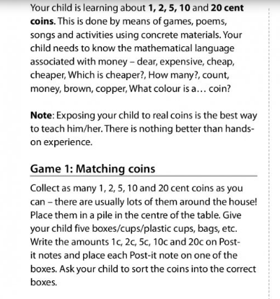

* Complete Pages 104,105,106 from the child’s Busy at Maths workbook.

**Gaeilge:**

**TG4 will be broadcasting a new programme called “Ar Scoil” weekdays at 10 a.m. – this will be similar to the RTÉ HomeSchool Hub but will be through Irish**. Our topic is “Lá Breithe” (Birthday). EDCO have kindly given access to the interactive Bua na Cainte programme which can be downloaded using the following steps:

1. Go to [www.edco.ie/bua](http://www.edco.ie/bua)
2. Select the file which suits your computer PC or MAC
3. Select the Class Level you require (Senior Infants), then click on it to start a download of the file
4. Once the download has completed, click on the file to install and follow the on-screen instructions.
5. A Bua na Cainte icon will appear on your desktop. Once you select this icon a login page will open where you will need to enter the details included below

**Login: trial**

**Password: trial**

Once you have accessed Bua na Cainte, **select “Ócáidí Speisialta”** from the themes, **Lá Breithe** and **Ceacht 5** (Lesson 5) and **Scéal** (Story) **.** There are lovely songs and interactive games which can all be done over the week (Please don’t feel under pressure to complete each game/activity that accompanies each lesson). This week, we will revise the song Lá Breithe Sona Duit which would be a lovely way to begin each lesson, it can be found under the “**Rainn**” tab at the bottom of **Lá Breithe** – please select **Lá Breithe Sona Duit** (Happy Birthday to You)

**Revise: Seo duit _____. (cárta, bronntanas, cáca)** (Here is a ____. (card, present, cake). **Go raibh maith agat.** (Thank you.) **Cad atá sa bhronntanas?** (What’s the present?). **Tá _____ sa bhronntanas. (cluiche, tarracóir, buachaill bó).** (It’s a ___. (game, tractor, cowboy).

**Ceacht 5:** Is based on Oisín’s birthday party and what happens at the party.

**Lá breithe Oisín a bhí ann inné.** (It was Oisín’s birthday yesterday.)

**Rinne Daidí cáca.** (Dad made a cake)

**Tháinig an madra isteach sa cistin.** (The dog came into the kitchen.)

**D’ith sé an cáca.** (He ate the cake.)

**Bhí fearg ar Dhaidí.** (Dad was cross.)

**Thosaigh Oisín ag gaire.** (Oisín started laughing.)

**Scéal: Cé atá ann?** (Who is there?)

The story is about Tiger’s 6th Birthday. All the animals are calling to Tiger’s house for his party. Each animal knocks on the door and Tiger asks “Cé atá ann?” (Who is there?). The animals answer ____ atá ann. (____ is here.). **(crogall –** crocodile; **sioráf –** giraffe; **nathair –** snake; **eilifint –** elephant**)**

**Activity:** After listening to the story you could point at different animals and ask Cé atá ann? The children should have the vocabulary from a few weeks ago and we’ve done animals previously in school also.

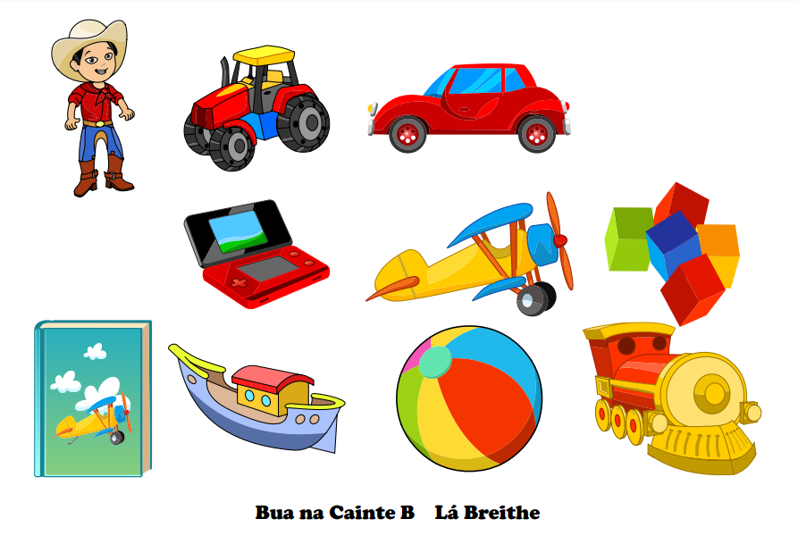

**S.E.S.E: (History, Geography, Science)**

We have outlined the learning objectives for these subjects below. **These activities are covered over a two-week period**.

**History:**

* Listen to, discuss, retell and record through pictures and other simple writing activities some stories from the lives of people who have made a contribution to local and/or national life and to the lives of people in other countries in a variety of ways e.g. The Lighthouse Keeper

To access The Lighthouse Keeper story please register with EDCO online:

1. Go to [www.edcolearning.ie](http://www.edcolearning.ie)
2. Enter username primaryedcobooks and then enter password edco2020
3. Once logged in please copy and paste this link into search bar <https://www.edcolearning.ie/Book/Page?bookId=book853&chapterId=chapter12&pageId=page61>
4. Select animation in top left-hand corner

* **Skills: Thinking like a historian:** What is a lighthouse?; What was Michael’s job?; What did he do?; Why are there no lighthouse keepers anymore? Are there any other jobs that used to be done by people but are now automated? (e.g. level crossings, ticket machines, self-service checkouts)
* **Questions:** the questions on pg. 57 can be completed orally.
* You could also use this as an opportunity to look at the Old Head of Kinsale Lighthouse and learn some facts about it – the children could draw pictures and write some facts in their SESE sketchbooks. If you are lucky enough to live within 5km of the Old Head why not take a walk and look at the signal tour and lighthouse. You could also look at it on Google Maps if going for a walk is not an option.

**Geography:**

* Identify, discuss and implement simple strategies for conserving water.

**Activities:**

1. Discuss the ways we use water every day.
2. Interactive activity available at (use login details above for EDCO): <https://www.edcolearning.ie/Book/Page?bookId=book853&chapterId=chapter12&pageId=page62>
3. Explain to your child that water is a precious resource and we must be mindful not to waste it. Ask your child some ways we might conserve (save) water.
4. Replay the interactive activity above and ask your child is the character is wasting/saving water.
5. SESE sketchbook – write 3 ways that you use water and draw some good habits when using water. (See link above for examples of good and bad habits – these could be a point of discussion also)

**Science:**

* Investigate how forces act on objects – float or sink
* Sort items based on whether they will float or sink

**Activity:**

1. Read: Who Sank the Boat by Pamela Allen <https://www.youtube.com/watch?v=C_cYb9RHKUQ>

Predict who might sink the boat; discuss what happens as each animal gets on the boat;

1. Explain to your child that whether an item floats or sinks depends on its density – how tightly packed together the material inside it is. A boat is very heavy but hollow, so it is not dense and can float. A marble is small and dense so it sinks.
2. The page below can be used as a guide, using your SESE sketchbook or a blank page you can draw the items you test. Remember to guess whether it will float or sink before testing!
3. **Challenge:** How can you make a plastic bottle sink? Try it out!

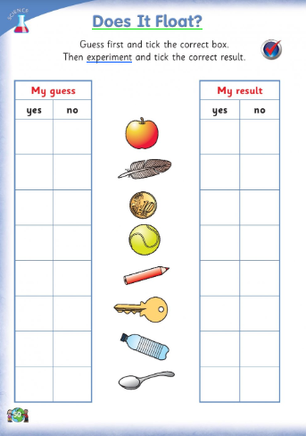

**SPHE:**

Story: Everybody Worries available on the class Padlet <https://padlet.com/aislingharte/snejnrsnr>

Everybody Worries encourages children to talk about what might be bothering them – take this as an opportunity to discuss your child’s worries and come up with ways that might help your child to deal with these worries e.g. they might be worried about their grandparents, a way to ease this worry would be to ring grandparents or even write them a letter/postcard. Below is a template activity sheet, this can be drawn out or recreated, it does not have to be completed on the sheet below.

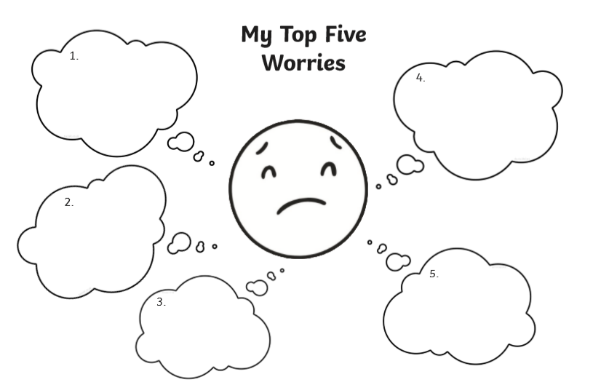

**PE:**

Athletics

Clare McSweeney (Athletics Coach) lesson 3 (Remember all previous athletics lessons are on the class padlet)

<https://www.youtube.com/watch?v=-d7zTFtDYpQ>

Challenge: This week we have included another Spell Your Name challenge!

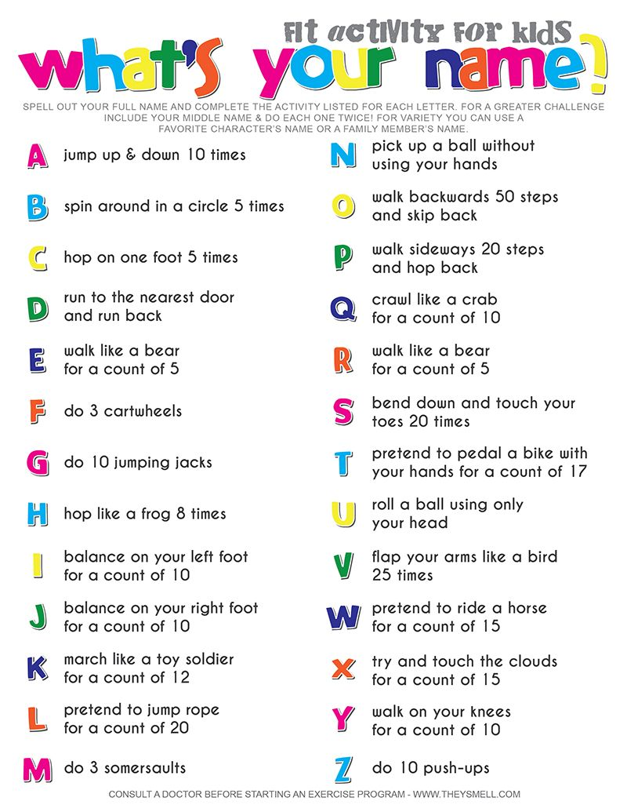

**Arts Education (Drama, Music, Art):**

**Music:**

**Listening and Responding**

Flight of the Bumblebee[**https://www.youtube.com/watch?v=aYAJopwEYv8**](https://www.youtube.com/watch?v=aYAJopwEYv8)

* Ask your child to listen to some/all sections of this piece (don’t tell them the name of the piece)
* Encourage your child to differentiate between sounds at different dynamic levels (loud and soft, getting louder and getting softer)
* Ask your child to identify when the music is getting faster or getting slower
* Ask your child draw what they feel when they listen to this piece.

**Art:**

Draw with Don (YouTube)

**Lesson: Draw a pink elephant**

[**https://www.youtube.com/watch?v=61hkbJ7MIws**](https://www.youtube.com/watch?v=61hkbJ7MIws)

**Drama:**

At the shop – This will link in nicely with the topic of money in maths

Set up a little shop in a corner of a room with for example household item, a cash register, shopping basket, shopping bags, real coins(that we have been learning in maths) .

Explore different characters and language through role play such as the shop keeper, the customer, the manager.

Explore language such as the cash register, receipt, change, trolley, basket, shopping bags, complaint, return, coins, money, entrance, exit, assistance, 1c, 2c, 5c, 10c, 20c. etc.