**Senior Infants Work:**



**Week Beginning 8th of June 2020**

8/06/20

Dear Parent/Guardian,

I hope this finds you and all your families well in this unsettling time. As we are now entering the final weeks of the school year, a time where we would usually be reducing the workload in school, we have decided to continue with this tradition to allow you all to get outside and enjoy the wonderful sunshine we are getting. June is usually a very busy time in school with school tours, Fun for all Day etc. We want to reassure the children that whilst we may not be able to enjoy this time together in school that we are coming up with ways to bring the fun to them. That in mind, next week the whole school will engage in an **Active Schools Week.** We are really looking forward to this and we hope you are too! This week will be the last week of school work as a result. We hope that you will enjoy the new challenges. As usual, our email addresses are below and would love if you would **continue to send one or two samples of work** that your child is proud of! Keep an eye on the class page of our school website as we will update it with some of the samples of work we receive. Our class Padlet activity page is still being updated regularly with both practical and online activities for you to complete with your child if you wish. <https://padlet.com/aislingharte/snejnrsnr>. If you have any queries, please feel free to contact us on the email addresses below. We would be delighted to be of any assistance. And parents remember all you can do is your best!

Ciara.oconnor@scoilnaomheltin.ie Aisling.harte@scoilnaomheltin.ie

Bernie.masterson@scoilnaomheltin.ie

Warmest Regards,

Ciara O’Connor and Aisling Harte

8/06/20

Dear Boys and Girls of Senior Infants,

Ms. O’Connor, Ms. Harte and Ms. Masterson miss ye all so much. We know ye are all being fantastic children for your moms and dads and that ye are remembering to wash your hands regularly! We know that ye are trying your best with your schoolwork and we are super proud of each and every one of ye. I’m sure you know that we are getting close to the summer holidays so we have decided to give you less work to do each week so that you can get outside and enjoy this wonderful sunshine. We will also be having an Active Schools week next week where we will be giving you lots of activities to do to keep active 😊

Last week, we were focusing on Fine Motor Skills like we do in Aistear. We know being at home can be hard and that you are missing your friends and school. We thought it would be a great idea to take some time to relax and practice some mindfulness. Moms and dads or whoever is at home might put on some relaxation music for you if you ask and you can take 5 minutes each day to relax. Below we have attached a choice board with lots of Yoga/Mindfulness activities. We would love if ye would pick three tasks a day.

We look forward to seeing all your work.

See ye soon,

Ms. O’Connor, Ms. Harte and Ms. Masterson

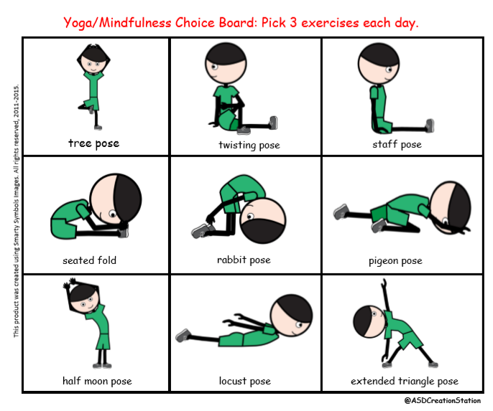

**English**:

As you are aware, we are using Over the Moon as our English Programme. Gill Education have kindly offered free access for parents to their online resources for the duration of school closures. To avail of this resource please visit: <https://www.gillexplore.ie/gill-explore-resources/over-the-moon-senior-infants-skills-book>

**Over the Moon work to be completed:**

1. Genre Story: Fun at the Campsite <https://content.yudu.com/web/1yssw/0A224cw/OTMSIGS9/html/index.html?refUrl=https%253A%252F%252Fwww.gillexplore.ie%252Fgill-explore-resources%252Fover-the-moon-senior-infants-skills-book%253FChapters%253D7662%2526ResourceTypes%253D11314>
2. While reading the story discuss the features of the genre with your child. The question below will help you with this

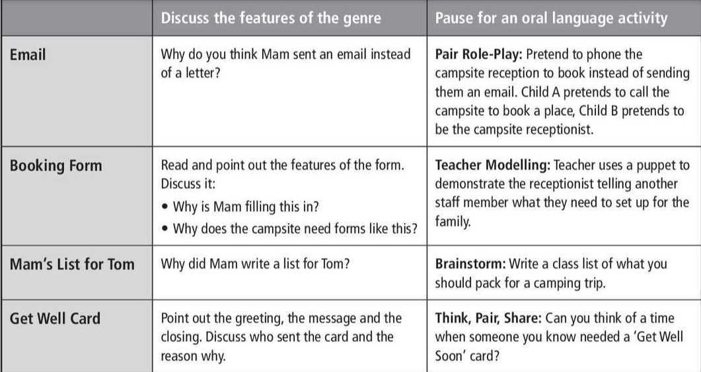

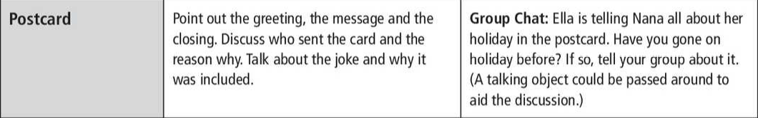

1. P.117 Analysing the genre
2. P.120 independent writing
3. P.121 Sight words: Comprehension

**Additional English work to be completed:**

1. My news (writing) – Today is …. It is …. My news is… - Please encourage children to write independently and to use their phonics to spell words.
2. Reading: <https://www.oxfordowl.co.uk/for-home/>
3. Handwriting: <https://educateplus.ie/ppresource/just-handwriting-senior-infants-pre-cursive%20>

p.40, 41,42 and revise 43

1. **Revise** all sounds and tricky words in word folders. **Learn** the next three tricky words. **If** your child has learned all tricky words please start at revising from the beginning and ask your child to write simple sentences using tricky words. Where possible, parents could give children a little test by selecting tricky words and asking their child to say the word – this will show where revision is needed. (See grid below)

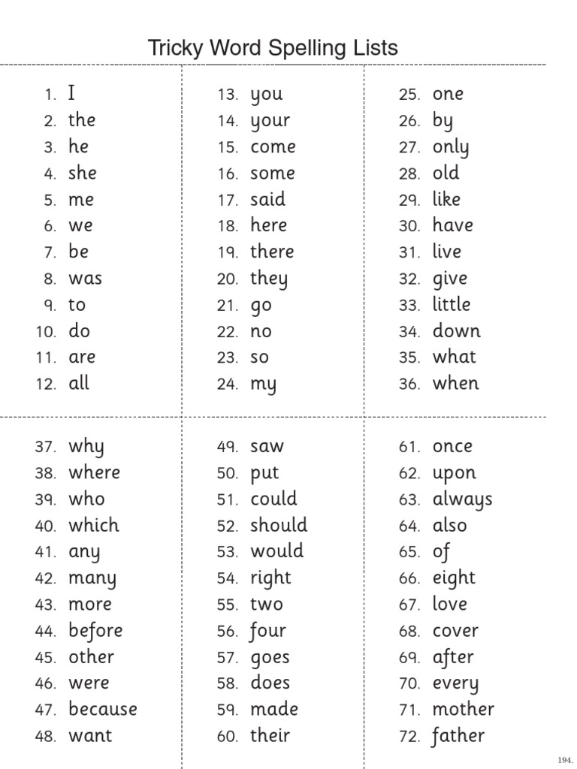

**Maths**:

This week we are going to continue with the concept of money. This is a very important chapter for the children to comprehend. We will also look at the topic of time; Summer and the days of the week.

• Complete Pages 122, 123, 124, 114, 119, 120, 121 from the child’s Busy at Maths workbook.

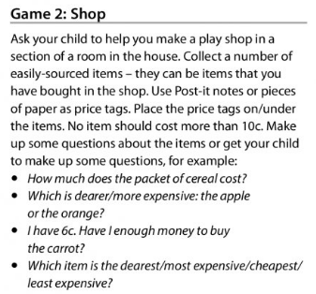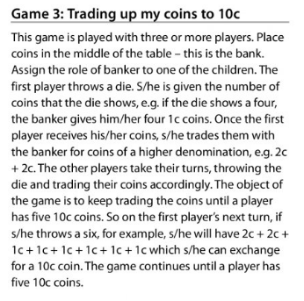

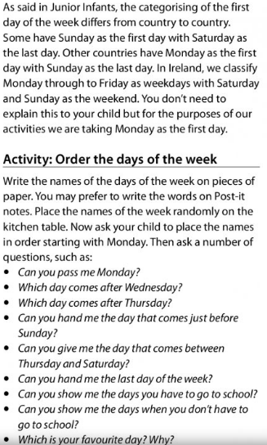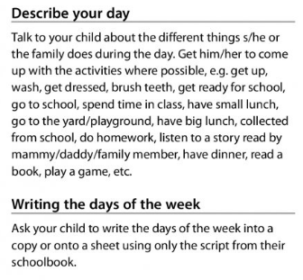

**Gaeilge:**

**TG4 will be broadcasting a new programme called “Ar Scoil” weekdays at 10 a.m. – this will be similar to the RTÉ HomeSchool Hub but will be through Irish**. Our topic is “Siopadóireacht” (Shopping). EDCO have kindly given access to the interactive Bua na Cainte programme which can be downloaded using the following steps:

1. Go to [www.edco.ie/bua](http://www.edco.ie/bua)
2. Select the file which suits your computer PC or MAC
3. Select the Class Level you require (Senior Infants), then click on it to start a download of the file
4. Once the download has completed, click on the file to install and follow the on-screen instructions.
5. A Bua na Cainte icon will appear on your desktop. Once you select this icon a login page will open where you will need to enter the details included below

**Login: trial**

**Password: trial**

Once you have accessed Bua na Cainte, **select “Siopadóireacht”** from the themes and **Ceacht 2** (Lesson 2) **.** There are lovely songs and interactive games which can all be done over the week (Please don’t feel under pressure to complete each game/activity that accompanies each lesson). This week, we will revise the song “**Istigh sa Zú”** which would be a lovely way to begin each lesson, it can be found under the “**Rainn**” tab at the bottom of **Siopadóireacht** – please select **Istigh sa Zú** (In the Zoo)

**Ceacht 2:** The first part of the lesson, is the characters asking permission to go somewhere (An bhfuil cead agam dul go dtí ____?). The second part of the lesson is counting animals in the zoo.

**An bhfuil cead agam dul go dtí ____, más é do thoil é? (an leithreas, an zú, an siopa bréagán)**

Please may I go to___ (the toilet, the zoo, the toy shop)

**Tá/Níl cead agat.** (Yes/No)

**Déan deifir.** (Hurry on)

**Cén fáth? Mar táimid ag dul abhaile.** (Why? Because we are going home)

**Comhair na hainmhithe**. (Count the animals)

**Aon ____ amháin, dhá ____, trí ____, ceithre _____, cúig ____, sé ____, (mhoncaí, eilifint, tíogar, leon, changarú, bhéar, nathair)**

(One ___, two ____, three ___, four _____, five ____, six _____, (monkey(s), elephant(s), tiger(s), lion(s), kangaroo(s), bear(s), snake(s).

**Activity:** Encourage your child to ask permission as Gaeilge – an bhfuil cead agam dul go dtí an leithreas? (May I go to the toilet?); an bhfuil cead agam dul go dtí an siopa? (May I go to the shop?) etc.

You could also have a few teddy bears/toys and ask your child to count them to practice counting.

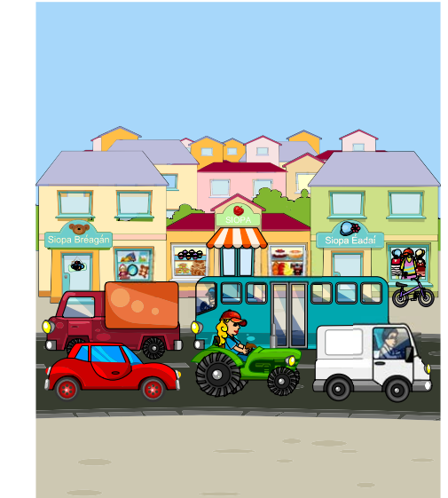

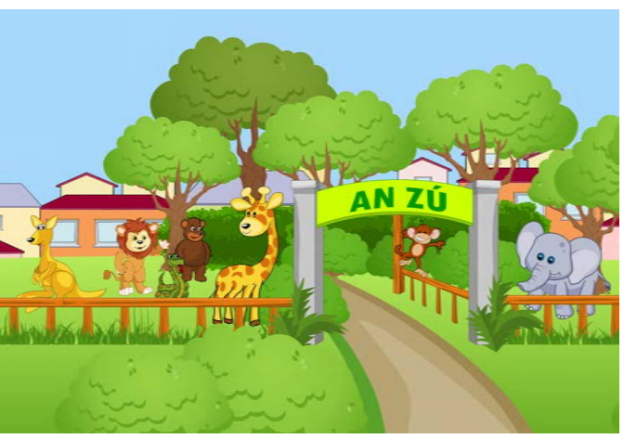

**PE:**

Athletics

Clare McSweeney (Athletics Coach)

<http://weplay.ie/week5/>

**This week’s challenges!**

This week we have set you some different challenges. Ones to get you thinking a bit more and creating, you might need some help from brothers, sisters or moms and dads to complete these but give them a go! We are looking forward to seeing some of your creations 😊

**We** **all have Different Shades of Skin!**

In light of the Black Lives Matter movement, we thought it would be a great opportunity to share this story with you and hopefully encourage discussion with your child. It is so important that children are educated in this area if we are help stop the inequality.

Some of you may have heard that there is a lot of fighting going on, particularly in America, at the moment and it is all because we all have different colour skin. We know that each one of us is unique and that also means that we have different colour hair, different colour eyes and different colour skin. There is nothing wrong with having different colour hair, eyes or skin it’s just part of being human! Boys and Girls we know how important it is to make sure everyone feels welcome and safe in our school and in our community so with your mom or dad please read the story below and talk about the different pictures and why you think it is important that everyone should be included and welcomed into our school and community.

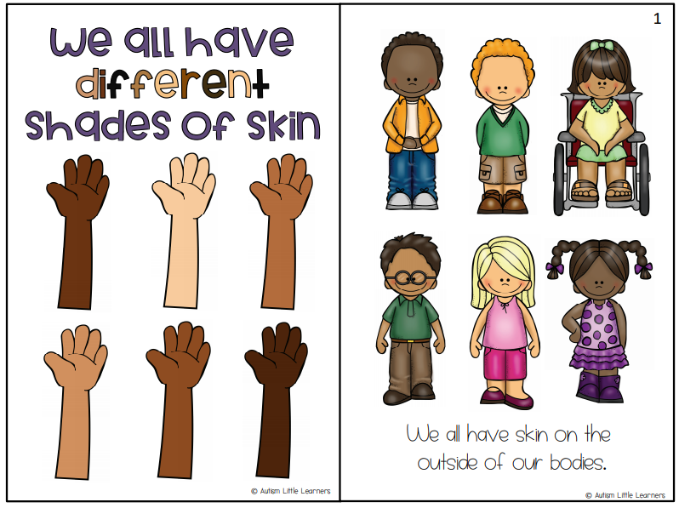

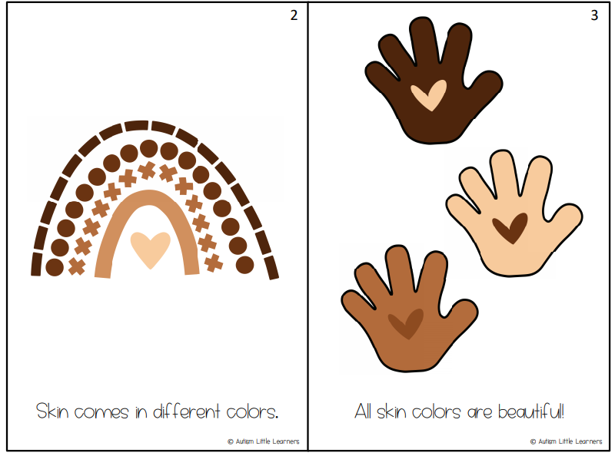

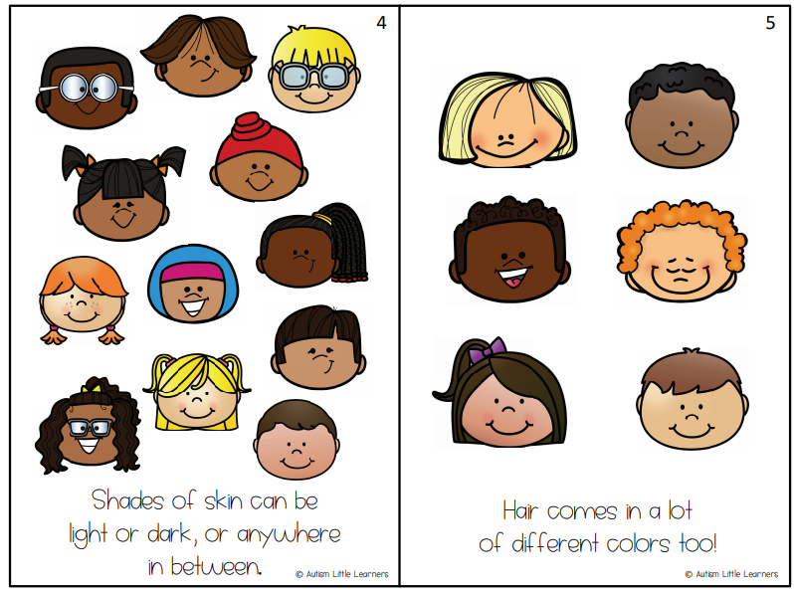

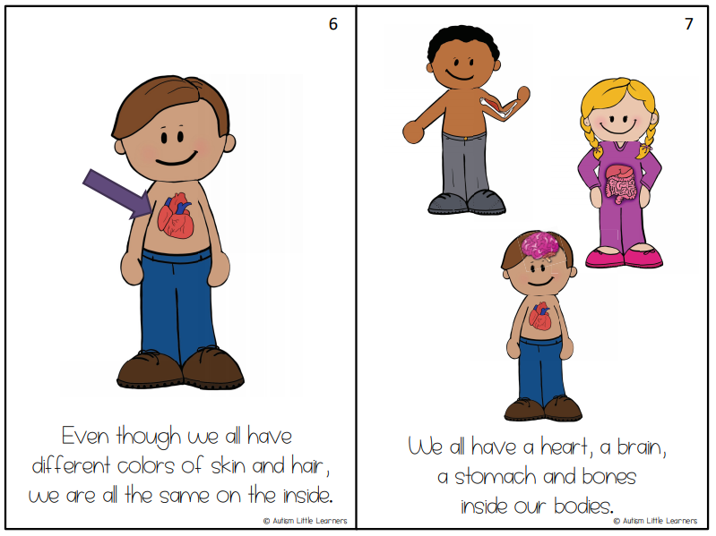

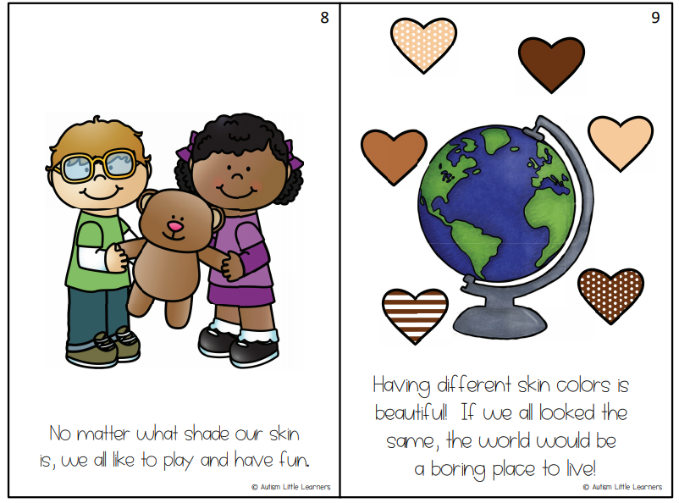

**Tie Dye Challenge:**

This week, we are going to try a fun art experiment and Ms. Harte has done a video to help you with this. All you need are some things you would find around your house! [https://www.youtube.com/watch?v=vEwUdBCIq6o&feature=youtu.be](https://www.youtube.com/watch?v=vEwUdBCIq6o&feature=youtu.be%20)  (Enjoy art class with Ms. Harte!!)

**You will need:**

Kitchen Towel

Washable Markers (e.g. Crayola)

Elastic band or hair bobble

Water (preferably in a spray bottle)

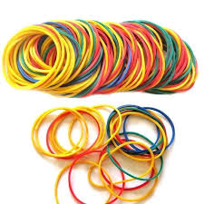

**Lockdown Memories:**

**You will need:**

500g Plain Flour

250g Salt

250ml Water

1. Mix all ingredients into a dough.
2. Roll out to desired size.
3. Press in handprints.
4. Bake in oven on lowest temperature for 3-4 hours.
5. Paint then varnish and seal.