

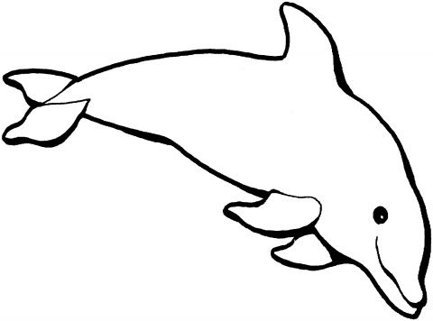

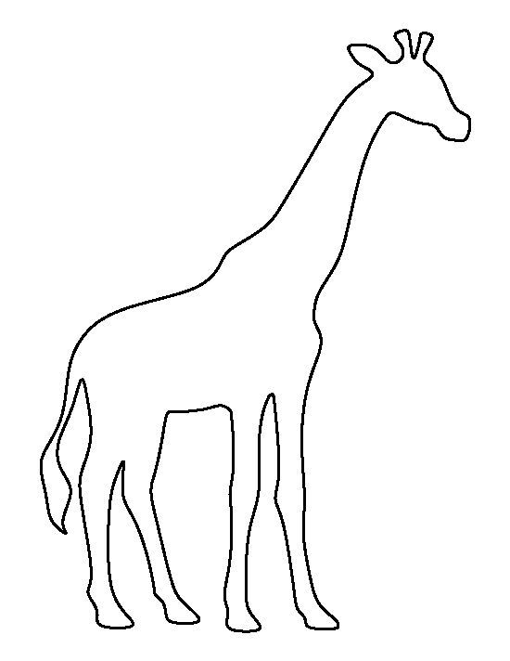



My Bus Ticket

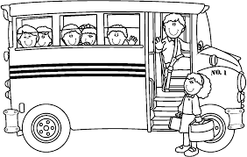

Name: _ _ _ _ _ _ _ _ _ _ _ _ _ _ _ _ _ _ _ _ _ _ _ _ _

Date: _ _ _ _ _ _ _ _ _ Time: _ _ _ _ _ _ _ _ _

Dublin Zoo

Scoil Naomh Eltin

What do I need to bring:

___________________________________________________________________________________________________________________________________________________________________________________________________________________________________________________________________