Home School Plan Monday 23rd – Friday 27th March

Hello parents/guardians, boys and girls!

The following is some schoolwork to keep you busy during the week.
You can write all answers into your Free Writing copy. Don’t forget to continue writing news or any stories into your Free Writing copy.

Mental Maths: Continue to do a column a day – on Monday do the Monday column, on Tuesday do the Tuesday column etc - just like you have been doing for Homework.
Art: Draw a picture of your favourite thing.
PE: GoNoodle, 10 @10

Reminder:
All companies are allowing free access to books online. All you have to do is sign up for free. The following companies are linked with the following books:
CJ Fallon – Busy at Maths and Small World (SESE)
Gill Explore – Reader (Fun at the Circus),Skills Books & Pupils digital resources.
Edco Learning – Bua na Cainte

Useful Websites:
Twinkl – This site has powerpoints and activities on numerous topics in all academic areas.
Magahigh – Maths online resource. As we have used this previously children can use the same username & password. I will be assigning tasks however children can use this page as they like.
‘Crickweb’ – 1st class – Maths & English activities
www.vooks.com – 1 month free – Keeps kids reading
www.oxfordowl.co.uk – Oxford Owl Ebook Reader Library#
Best wishes,
Ms. Dowling

SESE
Science – Hatching from an Egg.
Pg. 66 if accessing online.
- Discuss the new words with a parent.
- Write the sentences into your copy.

Geography – Aerial View of a Classroom
Pg. 75 if accessing online.
- Answer the questions in your copy.
- Give directions to get to a certain place in the classroom.
- Draw an aerial view of our classroom. Don’t forget to colour!

History:
Find out 5 facts about Charles Fort and write them into your copy.

Maths: Busy at Maths 1 (pg. 114-118 if accessing online)
Do one page a day. You can write the answer in your copy.

Remember our tens and units we were doing in class.
- Tens go on the left and units are always on the right.
- Find something at home that you can use instead of cubes e.g. pencils.
- Play the tens and units game that we played in class – Someone calls out a number and you make it using your pencils/ toys. For example, if you are given the number 23 – put 2 pencils where the tens go (representing 20 – 1 pencil represents a group of 10) and 3 pencils where the units go.
- You can draw an abacus on a blank piece of paper and place the pencils on this.

Don’t forget to keep practicing your tables. Play a game of table wars with someone at home.
Gaeilge: Bua na Cainte 1
Pg. 55 – 59 if accessing online. Click on Bua na Cainte 1 – Sa Bhaile
Bí ag léamh – Read each sentence. Go through the actions. Give an instruction – Bí ag ithe – child does the action, then child gives parent the instruction and parent acts it out.
Scríobh an freagair isteach sa cóipleabhar. Write the answer into your copy. Again, go through vocabulary and actions.

Go over the new vocabulary. If you have access to a printer join the dots and colour in the picture. ‘Taispéain dom spéir’ (Show me the sky) – Child points to where spéir is.

Go over vocabulary on this page. Go over the colours as Gaeilge at the bottom of the page. Again if you have access to a printer you can print this and colour.

Discuss new words with a parent. Write answers into your copy. Play a game of Feicim le mo shúilín around the house.
Cesit: Feicim le mo shúilín rud éigin a thosaíonn le _
Freagair: Feicim ______.

English:
Gill explore (free access to parents) allows you to access pupil digital resources linked to each story.
Fun at the Circus – Revise reading the story ‘Spring has Sprung’

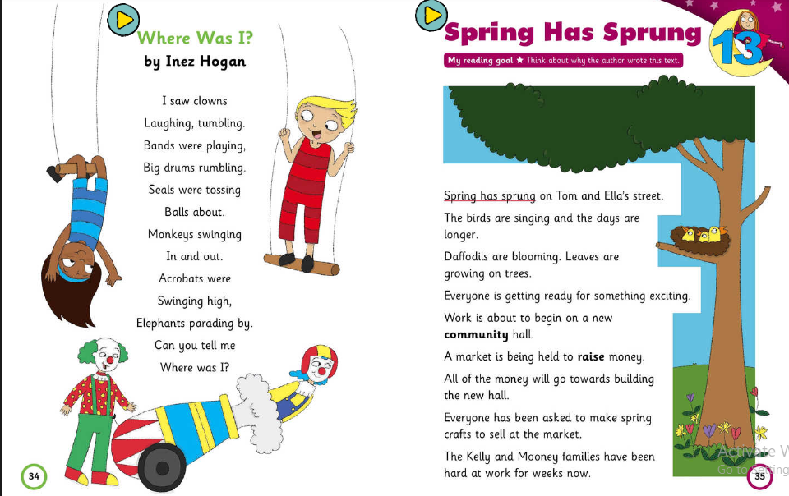

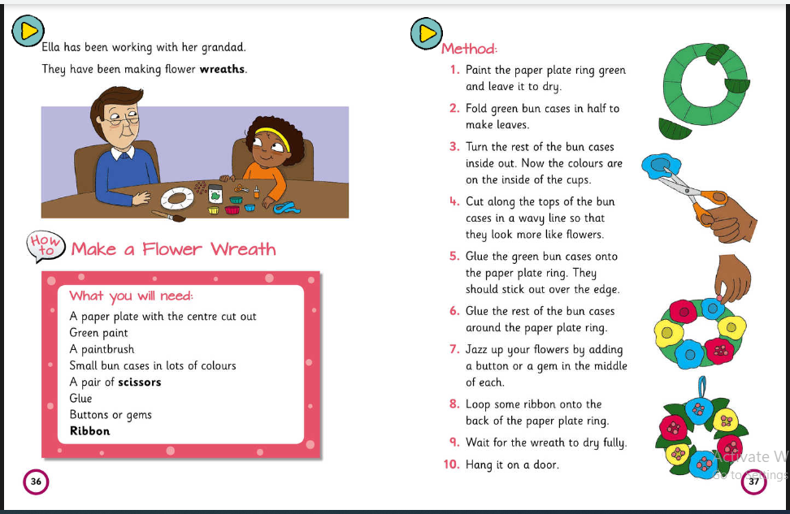
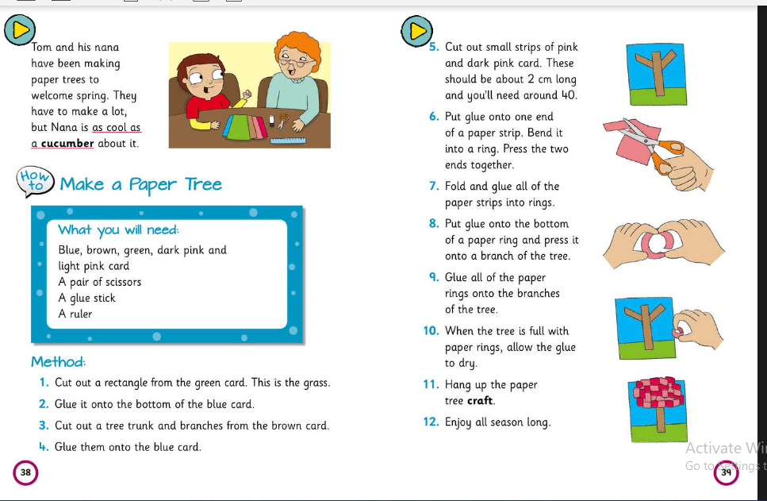
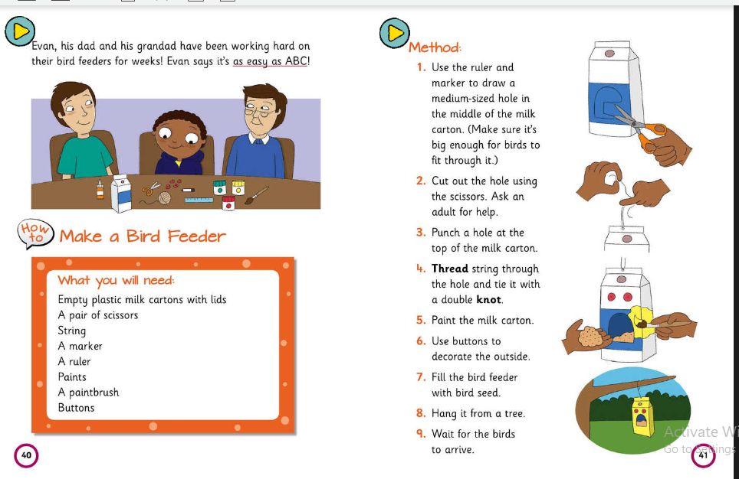
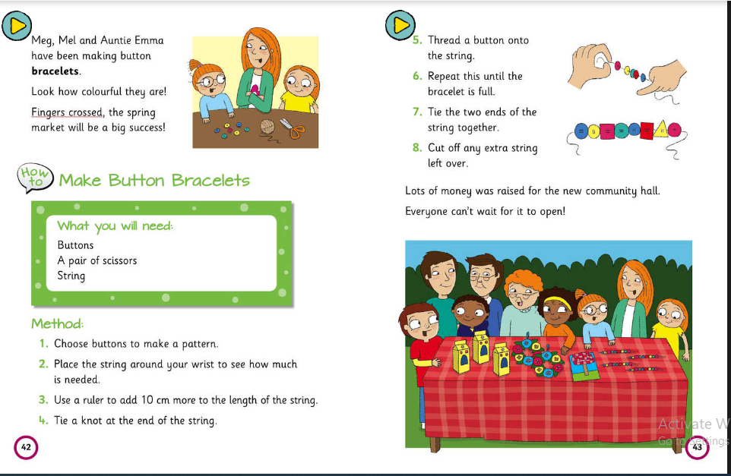
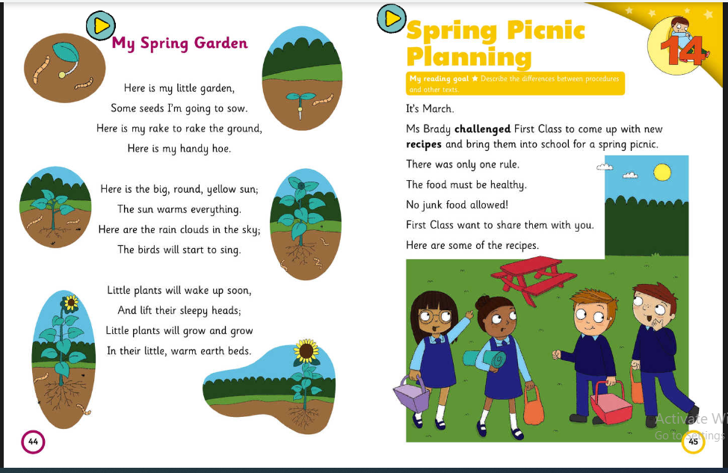

Spelling: ow sound
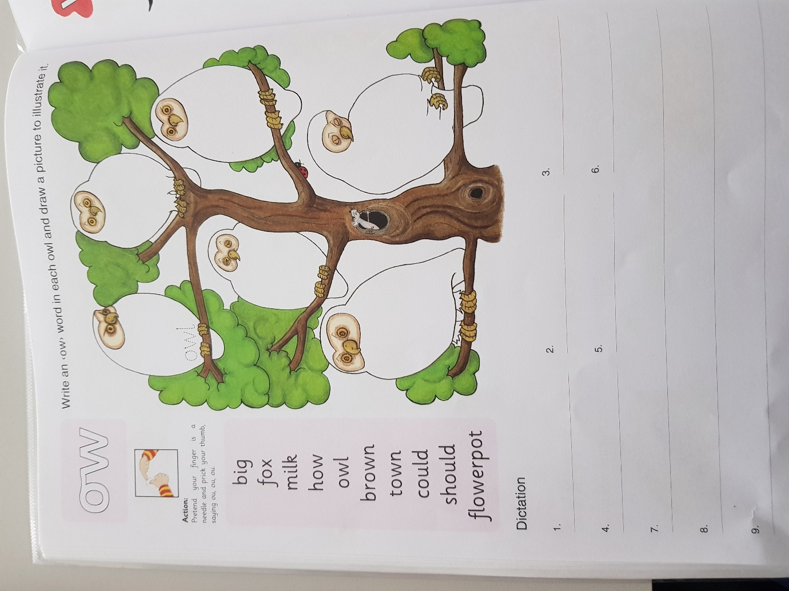

Skills Book:
Pg. 94, 96, 97 and 98 if accessing online.
Write all answers into your copy or on the sheet if you have access to a printer.

These questions are based on the story ‘Spring has Sprung’

SPHE:

Dear Parent,
Thank you for cooperating at this difficult time. I hope you and your family are all safe and well. The following are a few more websites to keep the children busy.
https://www.rte.ie/lifestyle/living/2020/0318/1123956-12-websites-to-keep-kids-busy-informed-entertained/
Best wishes,
D. Dowling

